Press Release

Control units for respirators:
RAFI ramps up production

HMI specialist RAFI has been producing capacitive control units for the HAMILTON-C6 mobile respirator station from Swiss medical technology manufacturer Hamilton Medical for around four years. This company, which has specialized since 1983 in the development of intensive respirator systems, ranks among the leading suppliers of intelligent high-end devices.
Currently, manufacturers and suppliers face major challenges due to the coronavirus pandemic and the resulting surge in demand for respirators. But, thanks to foresighted planning and management of manufacturing capacities, RAFI has succeeded in increasing production of its control units far beyond the usual volumes.

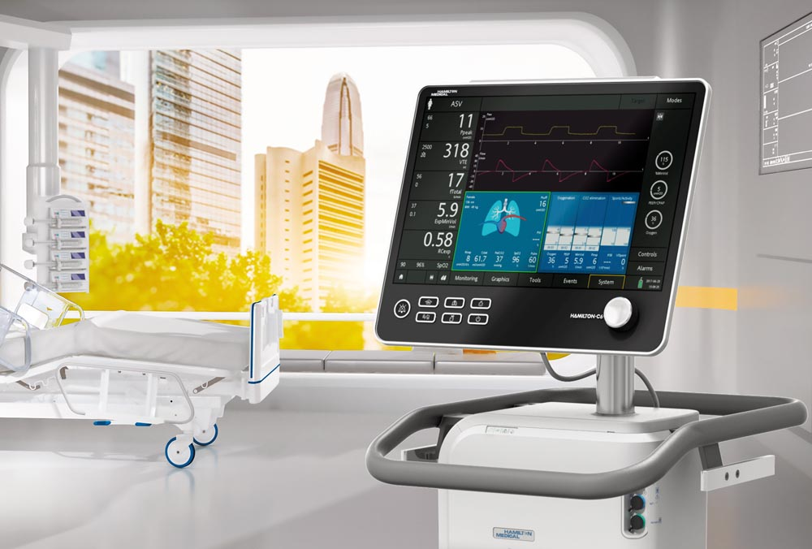
Photo: HAMILTON-C6 mobile respirator station from Hamilton Medical. The control unit, including capacitive 17" touchscreen, is manufactured by RAFI.

“As soon as the first alarming reports came in, we started thinking about how we could boost delivery capacity if necessary,” explains Max Mattes, the responsible RAFI Account Manager for the Systems business unit. “Our Purchasing department pro-actively contacted the relevant component suppliers. Our control units are an essential feature of the respirators. So of course we feel that RAFI has an indirect responsibility for ensuring the supply of life-saving medical devices.” The HMI manufacturer produces the control units entirely in-house. To increase the quantities at short notice, it had to flexibly adjust capacities in its production department and re-organize its order processing. The year before last, the company established its own clean room system for the production of glass sensors for capacitive touchscreens so that it could remain independent from Asian suppliers. Apart from the 17" touch sensors for the Hamilton respirators, RAFI also produces the diagnostic electronics and integrates the touch controllers on its own assembly lines. The front glass panels are also printed and fitted with electro-mechanical keypads in RAFI’s own facility. The hygiene-compliant silicon key switches are inserted into openings cut into the front glass panels, and snap-action contacts are installed underneath the actuators. Development and production of the control units, which RAFI supplies as fully assembled, ready-to-use assemblies, comply with the EN ISO 13485 medical standard.
“To meet the acute demand, we had to restructure a lot of our sequences. Obviously, all processes that are critical for the operating surfaces of the respirators come first right now,” says Mattes. “But of course we’re still doing everything to make sure all our customers get their supplies on time.”

Image/s: | HAMILTON-C6-ICU | Characters: | 2,478
File name: | 202005012_pm_bedieneinheit_beatmungsgeraet_en | Date: | 05-07-2020

About the RAFI group
Founded in 1900, RAFI today develops and produces electromechanical components and systems for human–machine interaction. The range of products includes pushbuttons, switches, touchscreens, control systems and electronic assemblies. RAFI products are employed in many industries including automation, medical technology, machine and plant engineering, road and railway vehicles, household appliances and telecommunication. The RAFI group operates internationally with more than 2,000 employees at sites in Germany, Europe, China, and the USA. Its headquarters are in Berg, Germany.

Contact:  RAFI GmbH & Co. KG  Artur Krug  Ravensburger Str. 128-134  88276 Berg, Germany  Phone: +49 751 89-1307  Fax: +49 751 89-1300  Email: artur.krug@rafi.de  Internet: www.rafi.de |  | gii die Presse-Agentur GmbH  Immanuelkirchstr. 12  10405 Berlin, Germany  Phone: +49 30 53 89 65-0  Fax: +49 30 53 89 65-29  Email: info@gii.de  Internet: www.gii.de

