Press Release

LVDT displacement sensors with pneumatic push rod

With the LVDT-ISDP and LVDT-ISAP series, Inelta Sensorsysteme offers special displacement sensors with pneumatic push rods for measuring ranges from 5mm to 50mm. The inductive sensors, which are available both with and without integrated measuring amplifiers in three device sizes, enable the exact determination of the position of, for example, sheet materials with a hysteresis-free measuring accuracy of up to ≤0.1mm. To prevent mechanical interference with the sensor technology, the push rod remains pneumatically retracted until the measuring process. For position detection, the measuring tip is extended by means of spring force and then pneumatically returned. The slim displacement sensors, manufactured to IP65 in a nickel-plated steel housing, are approved for use in temperature ranges from -35°C to +120°C and are shock and vibration protected in accordance with DIN IEC 68T2. Optionally, Inelta also supplies the units in IP67 or IP68 protection, with customized cable lengths, plug connection as well as in versions with a linearity tolerance below 0.25% or for an extended temperature range. On request, the sensors are also available with individual calibration. In addition to mounting blocks, clamping flanges, probe tips and pneumatic connections, various measuring amplifiers for DIN rail and PCB mounting as well as with cable connection are available as accessories.

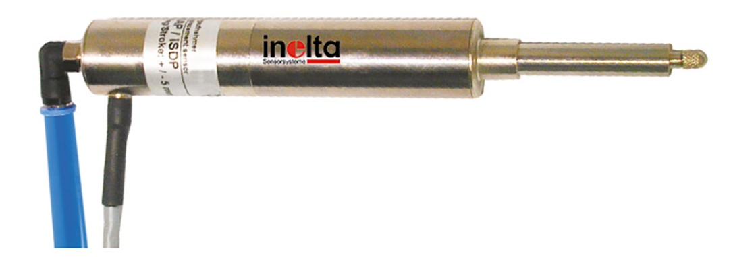

Caption: Inductive displacement sensors with pneumatically retracted push rod for precise positioning of sheet materials

Image/s: | lvdt_isdp_1000px.jpg | Characters: | 1390
File name: | 202303024_pm_lvdt-isdp_en.docx | Date: | 03-14-2023

About Inelta
Inelta Sensorsysteme GmbH & Co. KG with its headquarters in Taufkirchen near Munich has been developing, producing, and selling standard and customized sensor solutions for industrial applications for more than 25 years. Together with PIL Sensoren GmbH (Erlensee near Frankfurt/Main), an ultrasonic sensor system pioneer, and VYPRO s.r.o. (Trenčín, Slovakia), the company offers a wide range of products for measuring displacement and position as well as force, pressure and inclination measurement. The range includes force sensors, sensor signal amplifiers, pressure switches, capacitive sensors and ultrasonic sensors. Our portfolio is nicely rounded off with cable and connector assembly services.
Most of the group of companies’ customers are in industrial automation, mechanical engineering, hydraulics, medical technology as well as the aerospace industry. We especially focus on industry and customer-specific sensor solutions and are constantly expanding this focus with interdisciplinary know-how.
Contact:  Inelta Sensorsysteme GmbH & Co. KG  Reinhard Koch  Ludwig-Bölkow-Allee 22  82024 Taufkirchen  Germany  Phone: +49 89 452 245-0  Fax: +49 89 452 245-744  Email: reinhard.koch@inelta.de  Internet: www.inelta.de | gii die Presse-Agentur GmbH  Immanuelkirchstr. 12  10405 Berlin  Germany  Phone: +49 30 538 965-0  Fax: +49 30 538 965-29  Email: info@gii.de  Internet: www.gii.de

