Press Release

MIPI camera boards with largest sensor variety

Vision Components adapts the widest range of machine vision image sensors on MIPI camera modules and is the first manufacturer to also integrate non-native MIPI sensors such as Sony Pregius IMX250 and IMX252. The portfolio currently comprises 10 sensors with resolutions up to 20 MP and is being continuously expanded. It includes global shutter, rolling shutter, and global reset shutter versions. The latter offer significant price advantages over global shutter variants with roughly the same functionality. The compact, only 23.5 mm wide VC MIPI boards feature a 22-pin MIPI CSI-2 port for FPC (flexible printed circuit) cables. They are compatible to over 20 CPU boards including NVIDIA Jetson, DragonBoard, all Raspberry Pi boards, and all 96boards. Vision Components has developed proprietary shielded FPC cables that ensure robust data transfer and support the full bandwidth of the MIPI standard. The cables with two or four transmission lanes can be connected to 15 and 22-pin MIPI ports. Depending on the processor, this allows communication at twice the maximum speed of USB3 cameras.

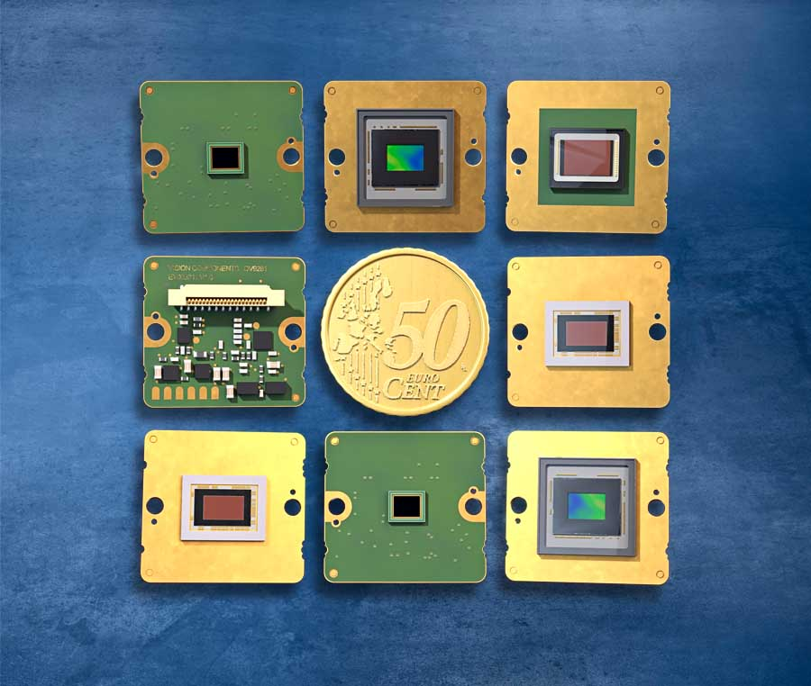
Caption: Vision Components manufactures MIPI camera modules with various camera sensors, even non-native ones

The MIPI standard supports relatively short transfer distances. Vision Components has developed repeaters for its 200 mm cables that can amplify the signal up to five times. This allows transmission paths to be extended to more than 1 m without compromising speed or signal quality. The repeater board also features a trigger interface (image trigger input/flash trigger output) and thereby augments CPU boards lacking these particular interfaces. The VC MIPI range furthermore includes lens holders, filter discs, adapter boards, as well as custom carrier boards and interface extensions. In addition, the manufacturer has already developed stable drivers for the most common hardware combinations and is steadily continuing this work to connect additional boards. Vision Components provides these drivers to its customers free of charge.
More about MIPI: www.mipi-modules.com

Image/s: | vc_mipi_scale | Characters: | 1935
File name: | 202002012_pm_mipi_program_en | Date: | 02-26-2020
About Vision Components
Vision Components is a leading international manufacturer of embedded vision systems. The freely programmable cameras with powerful onboard CPUs perform image processing tasks on their own without the need for an additional computer. Vision Components offers OEMs versatile Linux-based embedded systems for 2D and 3D image processing, supplied as board cameras or in protective casings. These are complemented by a growing range of ultracompact MIPI camera boards, which connect to a variety of different CPU boards. In addition, Vision Components offers software libraries and develops customized solutions on request. The team of experts can draw on extensive knowledge and over 20 years of experience with imaging applications. The company based in Ettlingen in southwestern Germany was founded in 1996 by Michael Engel, the inventor of the first industrial-grade intelligent camera. More world premieres followed, including the world's first intelligent vision sensors and the first-ever embedded 3D laser profiler. Today, Vision Components has sales offices in the United States and Japan and works with local partners in over 25 countries to provide consistent customer focus and readily available expertise throughout the world.

Contact:  Vision Components GmbH  Miriam Schreiber  Ottostr. 2  76275 Ettlingen  Germany  Phone: +49 . 7243 . 216 716  Email: miriam.schreiber@vision-components.com  Internet: www.vision-components.com | gii die Presse-Agentur GmbH  Immanuelkirchstr. 12  10405 Berlin  Germany  Phone: +49 . 30 . 538 9650  Email: info@gii.de  Internet: www.gii.de

