Press Release

Pump motor for thermal power station

Menzel Elektromotoren has manufactured a motor with a special flange for a condensate extraction pump in a combined heat and power plant. The original motor, which was over 30 years old, had to be matched exactly in all mechanical and electrical interfaces. Works included the manufacture of a flange with special dimensions for vertical installation along with repositioning the main terminal box. The energy supply company, already a customer of Menzel Italy, awarded the order because Menzel was able to fully confirm all technical requirements. Menzel’s MEBKGR series comprises high-voltage squirrel cage motors with an excellent price–performance ratio. For the current application, the manufacturer designed a 4-pole motor with size 500, 6000 V nominal voltage, 1100 kW nominal output, protection class IP55 and cooling type IC 411 (fin cooling with external fan). Menzel took the motor all the way through to commissioning, which was carried out to the customer's satisfaction.
More Menzel pump motor references: https://www.menzel-motors.com/pump-drive/

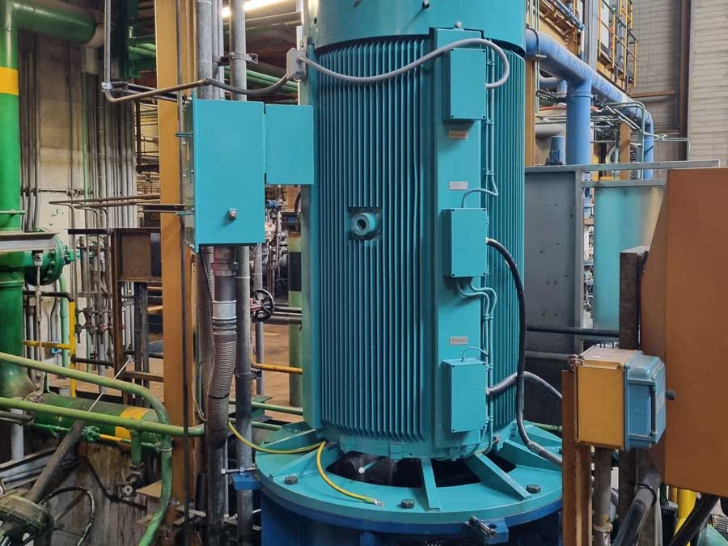
Caption: Menzel adapted the pump motor for the application – with a special flange and repositioned main terminal box

Image/s: | condensate_extraction_pump_motor |  | Characters: | 984
File name: | 202305010_pm_condensate_extraction_pump_en |  | Date: | 05-31-2023
About Menzel Elektromotoren
Based in Berlin, Menzel Elektromotoren GmbH has been manufacturing and distributing electric motors since 1927. The medium-sized company specializes in the delivery of large electric motors, including special models, within the shortest possible time. The product range comprises high and low voltage motors, DC motors, transformers, and frequency inverters. Services include motor production and short-term adaptation of stocked motors to application-specific requirements. In order to ensure fast deliveries to the customer at all times, the company maintains a very extensive inventory including more than 20,000 motors with a maximum performance of up to 15,000 kW. Qualified engineering, experienced staff, and state-of-the-art production and testing facilities help Menzel provide excellent reliability. Menzel operates subsidiaries in the UK, France, Italy, Spain, and Sweden, and cooperates with numerous partners worldwide.
Menzel is currently building a new motor plant in Hennigsdorf, near Berlin. The future headquarters will go into operation in early 2024.
Contact:  Menzel Elektromotoren GmbH  Mathis Menzel  Neues Ufer 19 – 25  10553 Berlin  Germany  Phone: +49 . 30 . 349 922-0  Email: info@menzel-motors.com  Internet: www.menzel-motors.com |  | gii die Presse-Agentur GmbH  Immanuelkirchstr. 12  10405 Berlin  Germany  Phone: +49 . 30 . 538 9650  Email: info@gii.de  Internet: www.gii.de

