Press Release

Photonics West:
MIPI cameras and components for fast, easy and cost-efficient embedded vision integration

At Photonics West (San Francisco, January 28 – February 2), Vision Components will be showcasing new MIPI camera modules and components that make the integration of embedded vision even faster, easier and more cost-efficient. The highlight will be the FPGA-based hardware accelerator VC Power SoM, which completes complex image processing calculations and transfers the results directly to a processor board. The tiny, 28 mm x 24 mm module facilitates development of embedded vision systems. It can be directly integrated into embedded vision mainboard designs as a module or combined with an I/O board with multiple MIPI interfaces. OEMs benefit from the VC Power SoM’s mature FPGA technology and comprehensive image processing functionalities and can at the same time freely choose the embedded processor board and use its full computing power for the main application. VC will also present a sneak preview of FPGA designs for applications such as color conversion, 1D barcode identification, epipolar correction, etc., which are currently being developed.

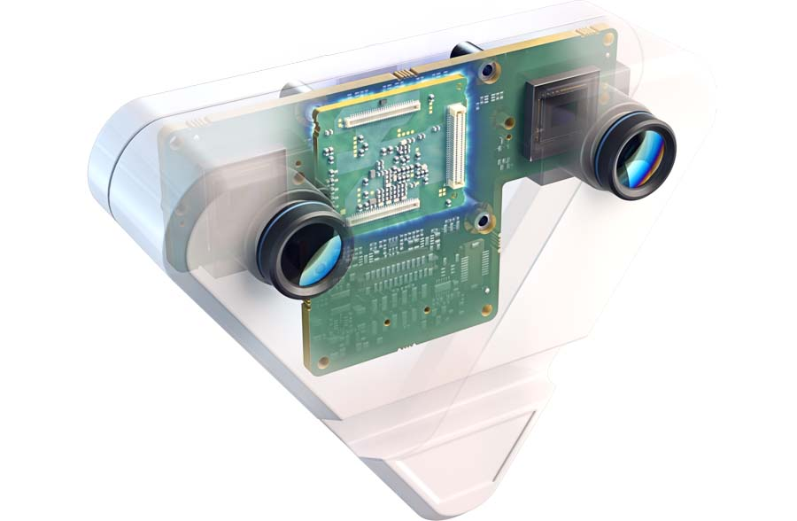
Caption: Sample application with VC Power SoM: stereo camera with direct data processing on the edge device

Vision Components will also present VC MIPI camera modules with SONY Pregius S series sensors as well as new MIPI cameras for SWIR and 3D/ToF applications. All products are developed and produced by Vision Components in Germany.

Vision Components at Photonics West
San Francisco, January 28 – February 2, 2023
Booth 3361

Image/s: | vc_stereo_camera_case_ghosting | Characters: | 1286
File name: | 202301011_pm_photonics_west_en | Date: | 2023-01-16
About Vision Components
Vision Components is a leading international manufacturer of embedded vision systems. The freely programmable cameras with powerful onboard CPUs perform image processing tasks on their own without the need for an additional computer. Vision Components offers OEMs versatile Linux-based embedded systems for 2D and 3D image processing, supplied as board cameras or in protective casings. These are complemented by a growing range of ultracompact MIPI camera boards, which connect to a variety of different CPU boards. In addition, Vision Components offers software libraries and develops customized solutions on request. The team of experts can draw on extensive knowledge and over 20 years of experience with imaging applications. The company based in Ettlingen in southwestern Germany was founded in 1996 by Michael Engel, the inventor of the first industrial-grade intelligent camera. More world premieres followed, including the world's first intelligent vision sensors and the first-ever embedded 3D laser profiler. Today, Vision Components has sales offices in the United States and Japan and works with local partners in over 25 countries to provide consistent customer focus and readily available expertise throughout the world.
Contact:  Vision Components GmbH  Jan-Erik Schmitt  Ottostr. 2  76275 Ettlingen  Germany  Phone: +49 . 7243 . 21670  Email: schmitt@vision-components.com  Internet: www.vision-components.com |  | gii die Presse-Agentur GmbH  Immanuelkirchstr. 12  10405 Berlin  Germany  Phone: +49 . 30 . 538 9650  Email: info@gii.de  Internet: www.gii.de

