Press Release

Automatic about-turn on rails

The German intra-logistics expert LOSYCO has expanded its LOXrail heavy-duty transport system, adding a new generation of AllRounder platform, now featuring semi-automatic steering. Unique among the solutions for intra-logistics rail transport, the new AllRounder keeps the payload on the same height level as it is re-oriented. The steering platform features a battery-powered servomotor that automatically re-positions the wheelsets as required. The steering is controlled via three buttons on the platform for 90° left or right turns or 180° rotation. Designed for payloads up to 15 tons, the AllRounder can run on LOXrail tracks with shaft diameter of either 25 mm or 40 mm. Its low height ensures ergonomic handling and easy loading, assembly and transport in one-piece flow production lines. The novel steering system saves time-consuming extra work for the installation of switches or turntables in the hall floor. Even with branching lines, it now suffices to firmly anchor LOXrail tracks and simple crossing elements in the floor. Thus, the entire intra-logistics rail system can be flexibly planned and efficiently implemented, even with complex track layouts, while the elimination of moving components in the hall floor makes it a particularly low-wear and low-maintenance solution.

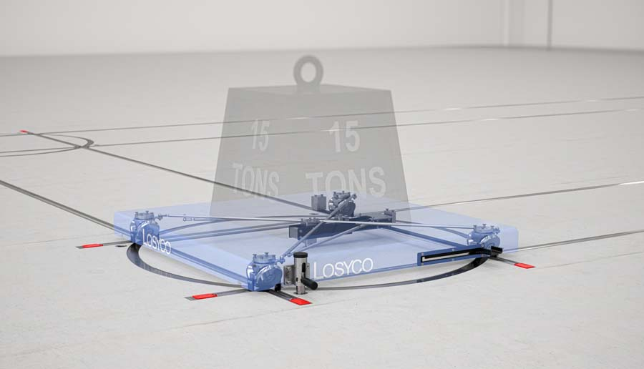
Caption: The next-generation AllRounder transport platform features semi-automatic steering for easy direction changes on intra-logistics rails

Image/s: | allrounder_lenksystem | Characters: | 1294
File name: | 202304053_pm_allrounder_en | Date: | 04-19-2023
About Losyco
LOSYCO designs, builds, and installs intra-logistics systems for the manufacturing industry. The company based in Bielefeld, Germany, was founded by experienced engineers in 2016. LOSYCO’s core product is the LOXrail® floor rail system for easy transport and precise positioning of loads weighing several tons. LOXrail transport platforms can be operated manually or with auxiliary drives. LOSYCO also supplies handling equipment such as chain and roller conveyors, material management and storage systems, as well as sound-proof cabins and machine covers. LOSYCO supports customers wishing to transform their production processes to lean manufacturing and continuous flow production. LOSYCO is a member of the DRECKSHAGE Family.
Contact:  LOSYCO GmbH  Member of the DRECKSHAGE Family  Manuel Granz  Walter-Werning-Str. 7  33699 Bielefeld  Germany  Tel.: +49 . 521 . 945 643-0  Email: info@losyco.com  Internet: www.losyco.com |  | gii die Presse-Agentur GmbH  Immanuelkirchstr. 12  10405 Berlin  Germany  Tel.: +49 . 30 . 538 965-0  Email: info@gii.de  Internet: www.gii.de

