Press Release

Highly overloadable mill motors in several sizes

Menzel Elektromotoren manufactures DC mill motors according to AISE standards. Few manufacturers produce this special type of motors nowadays, which feature extremely high overload capacity and mechanical load capacity. Menzel offers mill motors in various sizes: 802 / 803 / 804 / 806 / 808 / 810 / 812 / 814 / 816 / 818 / 62* (MEBG** series). AISE compliance ensures full interchangeability of the motors with existing machines. In addition, Menzel offers customer-specific adjustments and special solutions (e.g. for special load cycles or shock stressing, as well as metric mechanical adjustments). Menzel manufactures fully laminated mill motors by default. In special cases or on request, split case designs are also possible. Typical applications are in steel and aluminum rolling mills as well as mining.

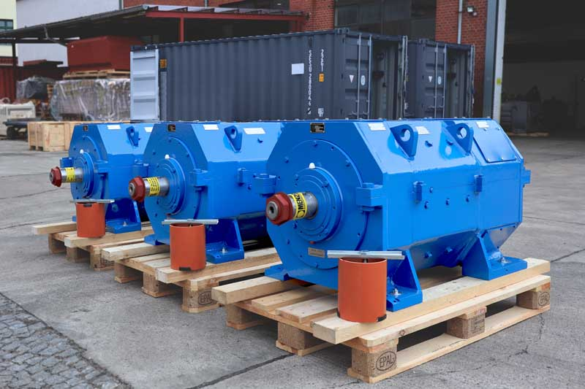
Caption: Menzel recently built three application-tailored mill motors

For a South European steel plant, Menzel has recently built three mill motors in size 812, with 200% overload capacity, 16 kW / 23 kW output power, protection class IP54, and cooling type IC 37. These are used on pinch and work rollers. For easy integration at the customer's site, Menzel designed the new mill motors with the same dimensions and electrical specifications as the existing motors. Working closely with the customer, the German company was able to compile all the necessary data despite the lack of technical documentation. Due to space restraints in the installation position, the cable outlets were positioned in exactly the same position as with the old motors. At the customer's request, Menzel built the motors with a split case to enable easy, fast revision and maintenance.
More reference projects for rolling mill drives: https://www.menzel-motors.com/rolling-mill-drive/

Image/s: | dc_rolling_mill_motors | Characters: | 1607
File name: | 202105018_pm_mill_motors_en | Date: | 06-01-2021
About Menzel Elektromotoren
Based in Berlin, Menzel Elektromotoren GmbH has been manufacturing and distributing electric motors for more than 90 years. The medium-sized company specializes in the delivery of large electric motors, including special models, within the shortest possible time. The product range comprises high and low voltage motors, DC motors, transformers, and frequency inverters. Services include motor production and short-term adaptation of stocked motors to application-specific requirements. In order to ensure fast deliveries to the customer at all times, the company maintains a very extensive inventory including more than 20,000 motors with a maximum performance of up to 15,000 kW. Qualified engineering, experienced staff, and state-of-the-art production and testing facilities help Menzel provide excellent reliability. Menzel operates subsidiaries in the UK, France, Italy, Spain, and Sweden, and cooperates with numerous partners worldwide.

Contact:  Menzel Elektromotoren GmbH  Mathis Menzel  Neues Ufer 19-25  10553 Berlin  Germany  Phone: +49 . 30 . 349 922-0  Email: info@menzel-motors.com  Internet: www.menzel-motors.com | gii die Presse-Agentur GmbH  Immanuelkirchstr. 12  10405 Berlin  Germany  Phone: +49 . 30 . 538 965-0  Email: info@gii.de  Internet: www.gii.de

