Press Release

Single source for complete generator sets for test fields

Menzel Elektromotoren supplies complete rotary converter sets for test fields, with motors and generators from its own production, frequency converters, transformers, all accessories, controls and software programmed in-house. The German manufacturer, who specializes in large machines, does all the calculations for the individually required performance profile as well as optional inspection and acceptance as a complete system. This service covers capacities up to 20MVA and voltages up to 13.8kV. The latest project is a 7.5MVA generator set for a transformer test stand. The system weighing a total of 60 tons is currently being shipped to Egypt where Menzel will see through its commission. It was important to the customer that Menzel especially configured the rotary converter set for this application and supplied it completely from a single source. The 7.5MVA synchronous generator and the 2.3MW squirrel-cage motor are Menzel products featuring high efficiency and great robustness. The frequency converters and transformers come from reliable partner companies and the control cabinets are supplied by Pawils Elektromaschinenbau, a member of the Menzel Group. The scope of delivery also includes various auxiliary drives, for example for forced fans, an oil supply system with a pump for lubricating the generator bearings, a coupling and numerous small parts. A special requirement was that the generator must work in 3-phase as well as 1-phase operation; Menzel planned a single to three phase switch for this purpose especially.
More information is available at https://www.menzel-motors.com/converter/.

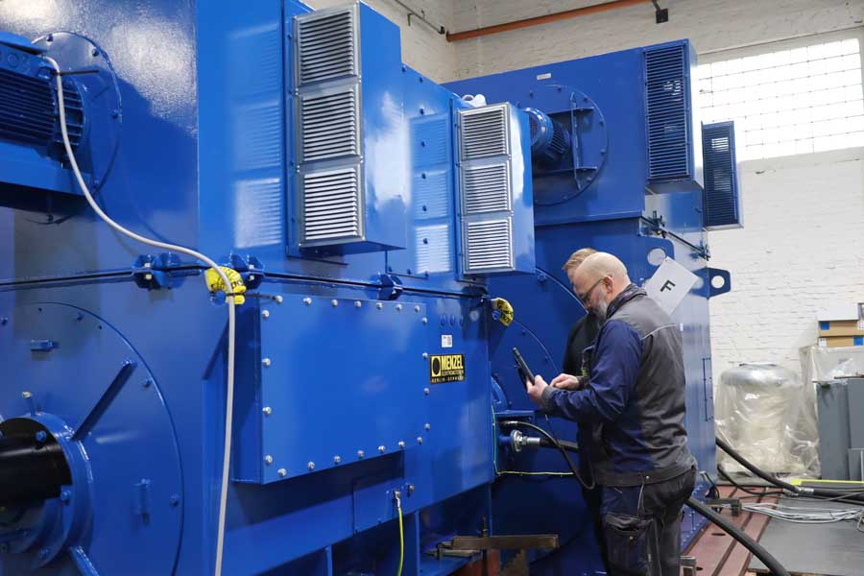
Caption: Menzel manufactured the motor and generator and planned the complete rotary converter set for measuring and testing power transformers

Image/s: | rotary_converter_set_egypt_transformer_tests | Characters: | 1617
File name: | 202211021_pm_rotary_converter_set_en | Date: | 11-22-2022
About Menzel Elektromotoren
Based in Berlin, Menzel Elektromotoren GmbH has been manufacturing and distributing electric motors since 1927. The medium-sized company specializes in the delivery of large electric motors, including special models, within the shortest possible time. The product range comprises high and low voltage motors, DC motors, transformers, and frequency inverters. Services include motor production and short-term adaptation of stocked motors to application-specific requirements. In order to ensure fast deliveries to the customer at all times, the company maintains a very extensive inventory including more than 20,000 motors with a maximum performance of up to 15,000 kW. Qualified engineering, experienced staff, and state-of-the-art production and testing facilities help Menzel provide excellent reliability. Menzel operates subsidiaries in the UK, France, Italy, Spain, and Sweden, and cooperates with numerous partners worldwide.
Contact:  Menzel Elektromotoren GmbH  Mathis Menzel  Neues Ufer 19 – 25  10553 Berlin  Germany  Phone: +49 . 30 . 349 922-0  Email: info@menzel-motors.com  Internet: www.menzel-motors.com |  | gii die Presse-Agentur GmbH  Immanuelkirchstr. 12  10405 Berlin  Germany  Phone: +49 . 30 . 538 9650  Email: info@gii.de  Internet: www.gii.de

