Press Release

6-MW high-voltage extruder motor speedily adapted

When large motors operating at high output fail, a replacement manufactured from scratch can hardly be the solution because of the long lead times and the resultant loss of production. Instead, customized configuration of a suitable standard motor is an economical alternative. A case in point: a petrochemical plant operator urgently needed to replace a failed extruder motor featuring 6000 kW rated power, 10 kV nominal voltage, requiring >57 kNm nominal torque. Originally, the extruder was driven by a squirrel-cage machine. However, a motor with similar design parameters was not readily available on the market. Fortunately, Menzel Elektromotoren based in Berlin, Germany, was able to offer a suitable three-phase slip ring motor. This design also offered significant advantages for the target application, driving an extruder, as it provides the required full torque from standstill.

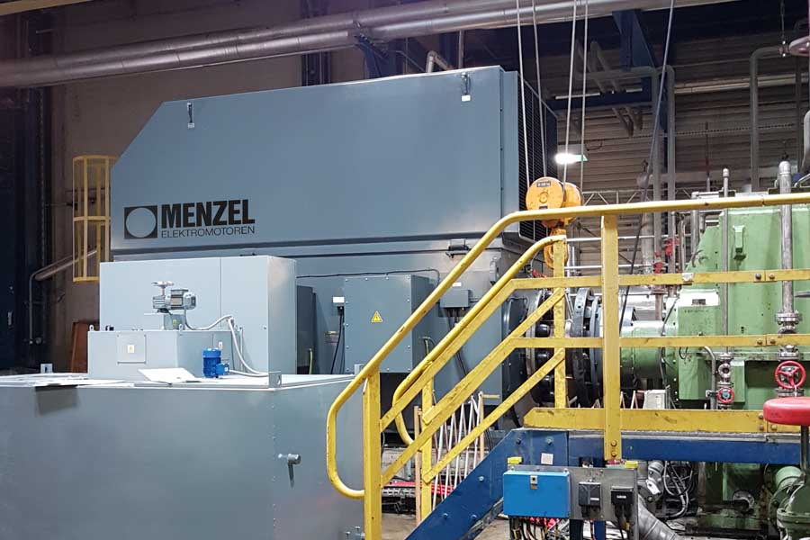
Caption: An off-the-shelf slip ring motor, adapted to fit the application at short notice, enabled the petrochemical company to restart its extruder plant as soon as possible

Menzel could quickly procure a starter for the slip ring motor as well as implement all necessary modifications in-house. Thanks to a delivery time of only two weeks, the customer restarted the extruder system at the earliest possible moment. The modular MEBSSL motor series is explicitly designed to enable flexible configuration for various applications and conditions. One of the most time-consuming jobs was fitting a bushing in the customer’s coupling hub, machining it from a diameter of 280 mm to 240 mm. In addition, Menzel manufactured adapter plates for the motor to adjust the shaft height from 800 mm to the failed motor center height of 900 mm. The replacement motor is designed with protection class IP55 and cooling type IC 611 with an air-to-air heat exchanger.
More information about high-voltage motors: https://www.menzel-motors.com/high-voltage-motors/

Image/s: | hv_extruder_motor | Characters: | 1667
File name: | 202107012_pm_hv_extruder_motor_en | Date: | 07-07-2021
About Menzel Elektromotoren
Based in Berlin, Menzel Elektromotoren GmbH has been manufacturing and distributing electric motors for more than 90 years. The medium-sized company specializes in the delivery of large electric motors, including special models, within the shortest possible time. The product range comprises high and low voltage motors, DC motors, transformers, and frequency inverters. Services include motor production and short-term adaptation of stocked motors to application-specific requirements. In order to ensure fast deliveries to the customer at all times, the company maintains a very extensive inventory including more than 20,000 motors with a maximum performance of up to 15,000 kW. Qualified engineering, experienced staff, and state-of-the-art production and testing facilities help Menzel provide excellent reliability. Menzel operates subsidiaries in the UK, France, Italy, Spain, and Sweden, and cooperates with numerous partners worldwide.

Contact:  Menzel Elektromotoren GmbH  Mathis Menzel  Neues Ufer 19-25  10553 Berlin  Germany  Phone: +49 . 30 . 349 922-0  Email: info@menzel-motors.com  Internet: www.menzel-motors.com | gii die Presse-Agentur GmbH  Immanuelkirchstr. 12  10405 Berlin  Germany  Phone: +49 . 30 . 538 965-0  Email: info@gii.de  Internet: www.gii.de

