Press Release

Hydrostatic level sensor for up to 20 m

EGE has extended its DGC line of hydrostatic level meters, adding a new sensor for measuring liquid media levels up to 20 m. The sensor consists of a measuring head with integrated electronics and an IP68 probe attached to a cable. The cable is up to 20 m long to ensure the probe can be lowered to the bottom of large tanks. The electronics unit is enclosed in a rugged stainless-steel housing with a G¾ thread for attachment, for instance on the tank cover. A line of LEDs integrated in the measuring head indicates the level at a glance. The sensor requires a 24 V DC supply. It can be used in ambient or media temperatures from -20 °C to +75 °C. Measured values are transmitted via a 4...20 mA output.

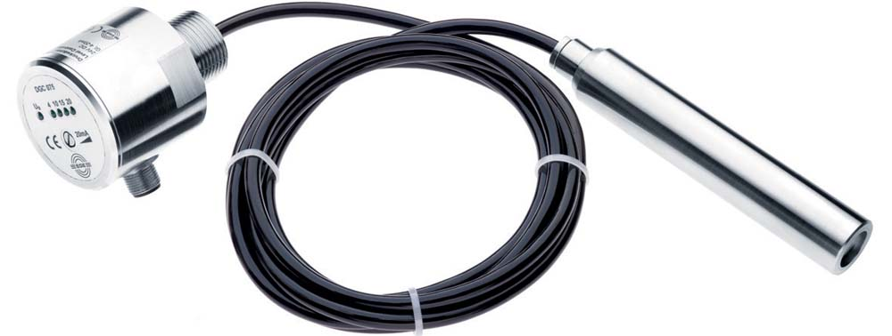
Illustration: The new DGC hydrostatic level meter measures liquid media levels up to 20 m

Illustrations: | druck-fuellstandssensor_dgc | Char.s: | 705
File name: | 201903048_pm_dgc_level_sensor_en | Date: | 06-12-2019
About EGE
EGE-Elektronik Spezial-Sensoren GmbH has been developing and manufacturing special purpose sensors for automation applications since 1976. The company serves leading international producers from a wide range of industries. Its product portfolio includes flow controllers, infrared, opto and ultrasonic sensors, capacitive proximity switches, light barriers and inductive proximity switches. EGE also provides sensors for highly sensitive applications, e.g. hazardous areas. The development department's highly qualified staff cooperates closely with all customers, ensuring continuous product updates and enhancement. A total of 89 employees, including 20 engineers and technicians, generate gross sales of approx. 19.5 million Euros worldwide.

Contact:  EGE-Elektronik Spezial-Sensoren GmbH  Sven-Eric Hiss  Ravensberg 34  24214 Gettorf  Germany  Phone: +49 . 4346 . 4158-0  Fax: +49 . 4346 . 5658  Email: info@ege-elektronik.com  Internet: www.ege-elektronik.com | gii die Presse-Agentur GmbH  Immanuelkirchstr. 12  10405 Berlin  Germany  Phone: +49 . 30 . 538 965-0  Fax: +49 . 30 . 538 965-29  Email: info@gii.de  Internet: www.gii.de

