Press Release

CONTA-CLIP connection technology at all about automation Zurich

At the first Swiss edition of the established all about automation tradeshow, which will take place in Zurich from 31 August to 1 September 2022, CONTA-CLIP will present its connection technology portfolio at booth A16. The family-run German company, one of Europe’s leading manufacturers of terminal blocks and cable management systems, has been producing electrical and electronic connection technology for virtually all industrial applications for over 40 years. The product range includes terminal blocks and accessories, cable management systems, electric and electronic control cabinet components, marking systems, housings, PCB terminals and PCB connectors.

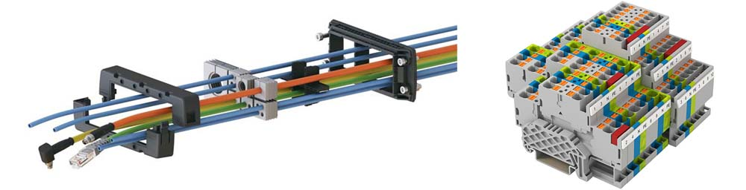
Caption: CONTA-CLIP will present the new KDSI-SR cable entry system and the innovative PRK terminal series with push-in wire connection at the all about automation Zurich trade fair

Tradeshow highlights will include the new KDSI-SR cable entry solution from the KDS range and the innovative PRK terminal block family featuring push-in wire connection. KDS cable entry systems provide maximum flexibility due to their modular design consisting of a one-piece frame, removable inlays and sealing elements. Cables and conduits of various sizes can be replaced at any time without disassembling the entire frame or removing plugs, while at the same time preserving the high IP66 ingress protection rating. This enables control cabinet manufacturers and machine builders to pre-configure their products with KDS cable entry systems without knowing the end users’ exact cabling requirements. The new PRK series is one of the most advanced push-in terminal block lines on the market today. This new, wide terminal range provides large diversity and particularly easy handling due to enlarged insertion channels, minimized engaging forces and integrated pushers. PRK terminals are extremely space-saving due to their tall design and wire insertion from above, which allows for minimal installation distance to wiring ducts.

Image/s: | aaa_KDSI_PRKD | Characters: | 1797
File name: | 202207010_pm_all_about_automation_zurich_en | Date: | 07-13-2022
About CONTA-CLIP
CONTA-CLIP is one of Europe’s leading manufacturers of electrical and electronic connection elements and cable management solutions. Based in Hövelhof, Germany, the medium-sized, family-run company has been producing electric and electronic connection systems for the process and automation industries since 1978. CONTA-CLIP supplies all industry sectors, focusing on railroad industries, shipbuilding, building automation, conveyor technology, machine and plant engineering and construction, instrumentation and control technology, control panel manufacturing, transformer manufacturing, and environmental technology. The company consists of many specialized branches: CONTA-CONNECT for electric connection technology, CONTA-CABLE for cable management systems, CONTA-ELECTRONICS for electronics and CONTA-CON for PCB edge connectors. Additionally, CONTA-CLIP provides services such as customizing housings and mounting rails, labeling and supplying user-specific electronic components.
Contact:  CONTA-CLIP  Verbindungstechnik GmbH  Franziska Klein  Otto-Hahn-Str. 7  33161 Hövelhof  Germany  Phone: +49 . 5257 . 9833 - 173  Email: franziska.klein@conta-clip.de  Internet: www.conta-clip.com |  | gii die Presse-Agentur GmbH  Immanuelkirchstr. 12  10405 Berlin  Germany  Phone: +49 . 30 . 538 965 - 0  Email: info@gii.de  Internet: www.gii.de

