Press Release

Bespoke pit fan motors with fin cooling

Menzel Elektromotoren has designed and manufactured three powerful 6600 V squirrel cage motors as integral components for pit fans. The customer specified cylindrical motor casings as compact as possible. The greatest challenge was to implement the required rated power of 1700 kW in cylindrical casings. Menzel therefore designed fin-cooled motors (cooling type IC 411) in frame size 630, an extremely unusual design for motors this large. The manufacture is complex but the result is optimal for the constricted installation conditions. In order to save additional space, all connection cables are routed out of the motors and the terminal boxes are mounted outside the fans. Since the driven fan wheels are mounted directly on the motor shafts, the motor bearing must compensate additional high loads: radial loads up to 20700 N and axial loads up to 27000 N. For the required bearing service life of 100,000 hours, Menzel implemented a special rolling bearing setup. In addition, the motors have a second shaft end for a holding brake. The three-phase squirrel cage motors are designed for operation on a frequency converter (duty type S9) with speed changes and reversal of the rotation direction. This allows the pit fans not only to ventilate the mine, but also to extract dangerous firedamp if necessary.
Surface-cooled motors from Menzel: https://www.menzel-motors.com/slip-ring-motor/ic411/

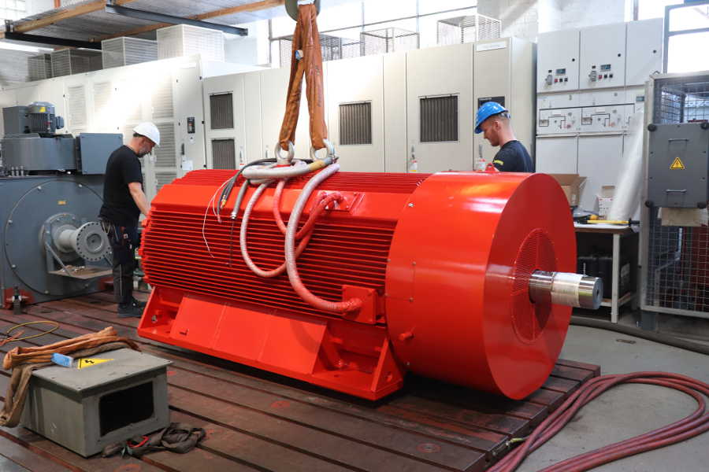
Caption: Menzel has tailored three-phase squirrel cage motors in frame size 630 for installation inside pit fans, including the manufacture of bespoke casings with cooling fins

Image/s: | menzel_pit_fan_motor | Characters: | 1312
File name: | 202209003_pm_pit_fan_motors_en | Date: | 09-14-2022
About Menzel Elektromotoren
Based in Berlin, Menzel Elektromotoren GmbH has been manufacturing and distributing electric motors since 1927. The medium-sized company specializes in the delivery of large electric motors, including special models, within the shortest possible time. The product range comprises high and low voltage motors, DC motors, transformers, and frequency inverters. Services include motor production and short-term adaptation of stocked motors to application-specific requirements. In order to ensure fast deliveries to the customer at all times, the company maintains a very extensive inventory including more than 20,000 motors with a maximum performance of up to 15,000 kW. Qualified engineering, experienced staff, and state-of-the-art production and testing facilities help Menzel provide excellent reliability. Menzel operates subsidiaries in the UK, France, Italy, Spain, and Sweden, and cooperates with numerous partners worldwide.
Contact:  Menzel Elektromotoren GmbH  Mathis Menzel  Neues Ufer 19 – 25  10553 Berlin  Germany  Phone: +49 . 30 . 349 922-0  Email: info@menzel-motors.com  Internet: www.menzel-motors.com |  | gii die Presse-Agentur GmbH  Immanuelkirchstr. 12  10405 Berlin  Germany  Phone: +49 . 30 . 538 9650  Email: info@gii.de  Internet: www.gii.de

