Press Release

From pinpoint IR temperature sensing to thermal imaging

For all industry applications that need real-time, accurate, detailed temperature data, Fluke Process Instruments provides rugged, high-performance noncontact infrared sensors and solutions. The comprehensive portfolio includes single spot pyrometers and two kinds of thermal imaging systems: linescanners and thermal cameras. Installed at a safe distance, these systems enable continuous temperature monitoring and control from -40 °C to 3200 °C. Each product range offers suitable wavelength models for various applications that can measure repeatably even under arduous conditions. Output options include analog signals, industrial protocols, OPC, and web server. Devices with analog and digital output types can be run simultaneously, for example, Profinet and video streaming. Various software packages capture, log, and visualize temperature data and allow users to configure hardware or software alarms.

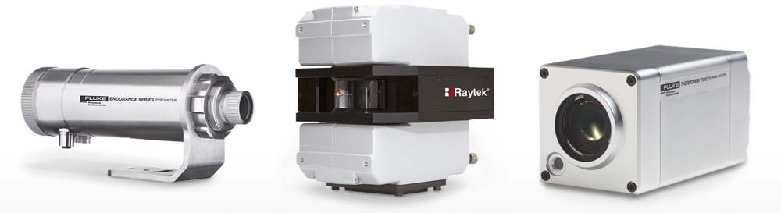
Caption: Infrared thermometers and thermal imaging systems monitor product quality and conformity and ensure the safety of processes and equipment

Spot pyrometers are designed for pinpoint measurement of small target areas. Ratio pyrometers can even measure objects that are smaller than the field of view, such as thin wires or molten streams of glass or metals. Unique sighting options – including remote video viewing with the Endurance sensor – enable users to ensure the measurement is always on target. Multiple-head, single-interface options plus networking of multiple devices can reduce installation costs. OEM miniature versions offer easy integration without the need for additional interfaces and are supplied with full protocol information and an optional hardware developer kit.
Thermal imaging systems can provide a full perspective on processes, equipment, and the surrounding environment. The Linescanner series enables real-time thermal imaging for continuous or batch processes, scanning moving objects line by line to create thermograms and temperature profiles. The ThermoView TV40 thermal camera is used to monitor continuous and discrete processes as well as equipment and facilities. Users can define multiple discrete temperature measurement areas (AOI) for temperature uniformity checks, hot and cold spot detection, and trend analysis. The complementary Pan and Tilt enclosure for the TV40 enables 360° monitoring at multiple heights. Single views can be combined in software to create a large matrix view. A comprehensive range of accessories is available to protect the devices from heat and cold and reduce contamination, ensuring reliable performance between planned maintenance. Each of these technologies has its strengths. For some applications or problems, a combination of different devices may be the best solution. The international technical and application support team advises customers on the optimal system configuration for their project.
More information: https://lp.flukeprocessinstruments.com/infrared-temperature-solutions/directindustry/eblast/

Image/s: | infrared_sensing_product_range | Characters: | 2744
File name: | 202102025_pm_ir_range_en | Date: | 03-10-2021
About Fluke Process Instruments
Fluke Process Instruments designs, manufactures, and markets a complete line of infrared temperature measurement and profiling solutions for industrial, maintenance, and quality control applications. Distributed worldwide under the Raytek, Ircon, and Datapaq brands, the products reflect the combined experience of over 150 years in manufacturing the world’s finest temperature measurement tools and devices.
About Fluke
Founded in 1948, Fluke Corporation is the world leader in compact, professional electronic test tools. Fluke customers are technicians, engineers, electricians, and metrologists who install, troubleshoot, and manage industrial, electrical, and electronic equipment and calibration processes.

Contact:  Fluke Process Instruments GmbH  Leonardo Trame  Blankenburger Str. 135  13127 Berlin  Germany  Phone: +49 . 30 . 478 008-0  Email: marketing@flukeprocessinstruments.de  Internet: www.flukeprocessinstruments.com | gii die Presse-Agentur GmbH  Immanuelkirchstr. 12  10405 Berlin  Germany  Phone: +49 . 30 . 538 965-0  Email: info@gii.de  Internet: www.gii.de

