Press Release

Intuitively adjustable airflow monitors with G1/2 thread for zone 2 and 22 hazardous areas

EGE announces the new LC 521 GSP-EX22 series of ATEX-certified screw-in airflow monitors with G1/2 thread for easy parameterization. The stainless-steel category 3 sensors have a 0.5 m/s to 20 m/s detection range. They are suitable for flow monitoring of gaseous media in zone 2 and 22 hazardous areas. They are installed in supply or exhaust air ducts with a screw adapter with a G1/2 female thread. The sensors are available in lengths of 32 mm, 49 mm, 101 mm or 151 mm. In applications with a specified air flow, users can easily set the limit value via the integrated potentiometer. The flow state is indicated by a three-color light on the housing front and transmitted for further processing by a PNP switching output. When the limit value is exceeded, the light changes from red to yellow, a further increase in the flow velocity is signaled by a green light. All variants have an IP67 protection rating and can be used in ambient temperatures between -10 °C and 60 °C. They are connected via a 2 m long fixed PUR cable. The sister series LC 518 GSP-EX22 comprises 80 mm long airflow monitors with an M18 thread.

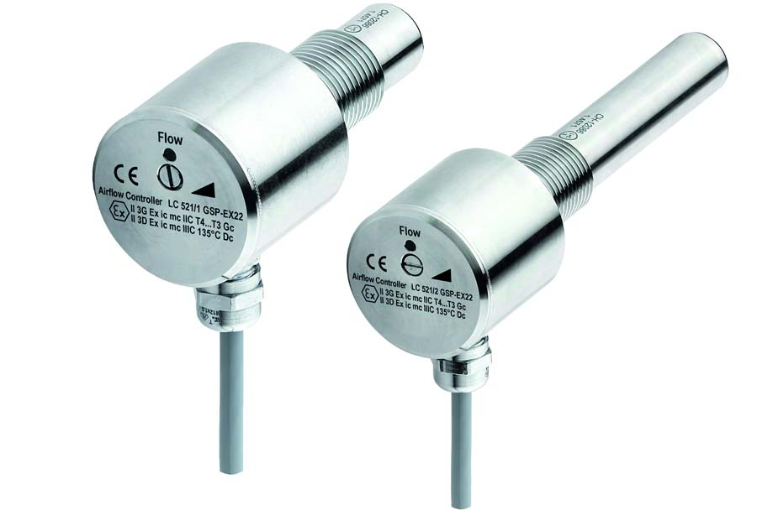
Bild: ATEX-certified airflow monitors from EGE’s new LC 521 GSP-EX22 series

Image/s: | LC_521_GSP-EX22_luftstromwaechter | Characters: | 1131
File name: | 202206010_pm_airflow_monitors_lc_521_gsp-ex22_en | Date: | 09-28-2022
About EGE
EGE-Elektronik Spezial-Sensoren GmbH has been developing and manufacturing special purpose sensors for automation applications since 1976. The company serves leading international producers from a wide range of industries. Its product portfolio includes flow controllers, infrared, opto and ultrasonic sensors, capacitive proximity switches, light barriers and inductive proximity switches. EGE also provides sensors for highly sensitive applications, e.g. hazardous areas. The development department's highly qualified staff cooperates closely with all customers, ensuring continuous product updates and enhancement. A total of 130 employees, including 20 engineers and technicians, generate gross sales of approx. 19.5 million Euros worldwide.
Contact:  EGE-Elektronik Spezial-Sensoren GmbH  Sven-Eric Hiss  Ravensberg 34  24214 Gettorf  Germany  Phone: +49 . 4346 . 4158-0  Email: info@ege-elektronik.com  Internet: www.ege-elektronik.com |  | gii die Presse-Agentur GmbH  Immanuelkirchstr. 12  10405 Berlin  Germany  Phone: +49 . 30 . 538 9650  Email: info@gii.de  Internet: www.gii.de

