Press Release

LogiMAT exhibition: a new turn for flexible heavy-duty intra-logistics transport

At the 2019 LogiMAT exhibition in Stuttgart, Germany, intra-logistics expert LOSYCO (Hall 7, Stand B09) presents new add-ons to its LOXrail program. Designed to enable comfortable, flexible, and efficient transport on rails, these innovative features and solutions facilitate heavy-goods handling in assembly lines for machinery and other bulky products. A new system architecture with guidable transport platforms with an integrated brake has its trade fair premiere. The mechanical guiding system mounted on the underside of the platform enables users to change the orientation and properly realign bulky products and heavy machines that weigh up to 10 tons – all without compressed air or power. Novel, freely rotating wheelsets with optimized rolling characteristics enable easy turning of the platforms. Thus, the newly designed platforms can be navigated without lifting the payload, saving time and effort.

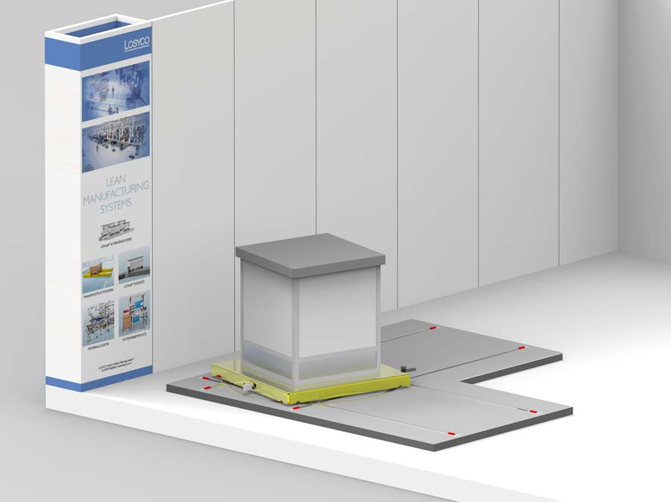
Illustration: At the 2019 LogiMAT, LOSYCO presents new intra-logistics rail transport platforms with integrated guiding and braking (Hall 7, Stand B09)

The low-profile platforms are especially easy to load and thereby ideal for one-piece flow production and assembly lines. The track layout can be flexibly adapted to the individual plant at significantly reduced installation costs. The entire conveying system is very low-maintenance and especially dirt-resistant. All components are robust and highly durable. The rails are firmly anchored in the hall floor. An also newly developed brake system ensures ergonomic, safe, and smooth braking of the loaded trolley. The pedal-actuated brake functions independent of the hall floor. In addition, LOSYCO shows a cross section of its standard program for heavy-load transportation. Two versions with 25 mm or 40 mm wide rails are available with corresponding single or double wheelsets for payloads from 16 kN to 100 kN. A team of experts at the exhibition booth stands ready to advise manufacturers about the wide range of possible configurations and ways to integrate the LOXrail system.

Illustrations: | lenkplattform | Char.s: | 1897
File name: | 201901033_pm_logimat_en | Date: | 01-31-2019
About Losyco
Based in Bielefeld, Germany, Losyco designs, manufactures, and deploys intra-logistics systems for industrial customers. Founded by experienced engineers in 2016, the company's first core product is LOXrail®: with this novel round bar rail system, loads weighing several tons can be easily moved around, precisely to the desired spot. It can be operated manually or with auxiliary drives. Losyco also supplies conveying and handling equipment such as chain and roller conveyors, material management and storage systems, sound-proof cabins, and machine covers. In addition, Losyco offers support and guidance for customers wishing to transform their production processes to implement lean manufacturing and continuous flow production. Losyco is a member of the DRECKSHAGE Family.

Contact:  LOSYCO GmbH  Member of the DRECKSHAGE Family  Derek P. Clark  Walter-Werning-Str. 7  33699 Bielefeld  Germany  Tel.: +49 . 521 . 945 643-0  Fax: +49 . 521 . 945 643-399  Email: info@losyco.com  Internet: www.losyco.com |  | gii die Presse-Agentur GmbH  Immanuelkirchstr. 12  10405 Berlin  Germany  Tel.: +49 . 30 . 538 965-0  Fax: +49 . 30 . 538 965-29  Email: info@gii.de  Internet: www.gii.de

