Press Release

E-BOX: Emergency stop type with additional control component

RAFI has extended its E-BOX product family for remote-location emergency stop buttons by a version with an additional control component. Apart from the emergency stop function, the slimline boxes can additionally feature either a pushbutton, a selector button, or a keylock switch from the RAFIX 22 FS+ control component series. This means they offer a further control option for remote applications without the need for extra cables. The housing dimensions of 109 mm x 40 mm x 29 mm make the E-BOX range ideal for attachment to 40-mm profile rails. The mounting clip is easy to attach to the profile rail groove via the single screw hole, then the E-BOX is simply snapped on without the need for tools. Alternatively, two screw holes are available for easy mounting on flat surfaces. RAFI supplies its E-BOX ready for connection. The M12 terminal means the control unit can be put into operation immediately without any need for wiring. The E-BOX comes in IP65 degree of protection and is designed for use in a temperature range of −25°C to +70°C.

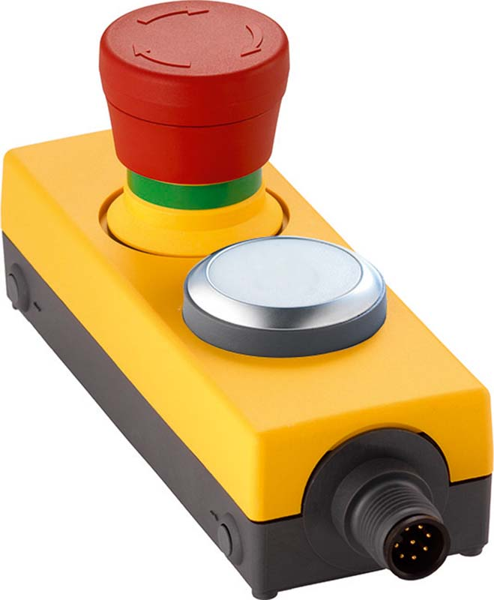
Caption: E-BOX with emergency stop and additional control component

Image/s: | E-Box_Not-Halt_1DT_weiss | Characters: | 1048
File name: | 202106006_pm_e-box_e-stop_pushbutton_en | Date: | 06-01-2021
About the RAFI group
Founded in 1900, RAFI today develops and produces electromechanical components and systems for human–machine interaction. The range of products includes pushbuttons, switches, touchscreens, control systems and electronic assemblies. RAFI products are employed in many industries including automation, medical technology, machine and plant engineering, road and railway vehicles, household appliances and telecommunication. The RAFI group operates internationally with more than 2,000 employees at sites in Germany, Europe, China and the USA. Its headquarters are in Berg, Germany.

Contact:

RAFI GmbH & Co. KG
Artur Krug
Ravensburger Str. 128-134
88276 Berg
Germany
Phone: +49 . 751 . 891 307
E-Mail: artur.krug@rafi-group.com
Internet: www.rafi-group.com

