Press Release

P53 hygienic ultrasonic sensor recertified

PiL Sensoren GmbH has again received the Hygenic Design Re-Qualification for its P53 series hygienic ultrasonic sensors including the associated food grade mounting glands. The fully encapsulated sensors with a housing made of stainless steel 1.44.4 in protection class IP69k were specially developed for use in hygienic food areas. P53 is available with housing diameters of 18 mm or 30 mm. ECOLAB certification ensures that the sensors can be cleaned with P3-topactive OKTO, P3-topactive 200, P3-topax 52, P3-topax 66 and P3-topax 990 detergents and disinfectants. For rough industrial applications without hygienic requirements PiL offers the robust "Steel Head" ultrasonic sensors also with external thread for simplified mounting.

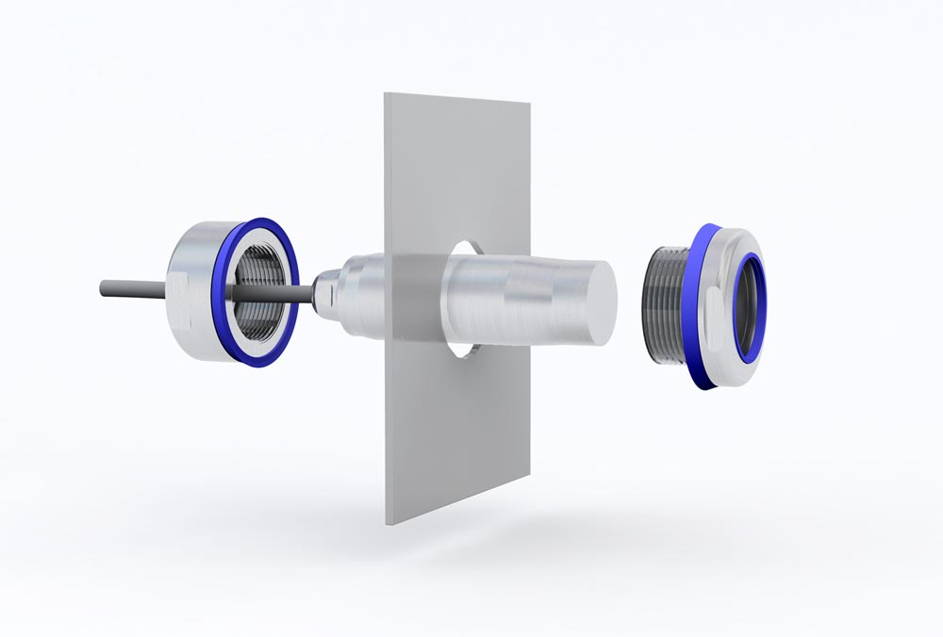
Caption: P53 series hygienic ultrasonic sensors including the associated food grade mounting glands has received the Hygenic Design Re-Qualification

Image/s: | P53_mit_Montagehalterung | Characters: | 735
File name: | 202209009_pm_p53_re-certified_en | Date: | 09-14-2022
About PIL
PiL Sensoren GmbH, with its headquarters in Erlensee near Frankfurt/Main is a pioneer of ultrasonic technology and has been developing, producing, and selling standard and customized sensor solutions for industrial applications since 1990. Together with Inelta Sensorsystem GmbH & Co. KG (Taufkirchen near Munich) and VYPRO s.r.o. (Trenčín, Slovakia), PiL offers a wide range of products for measuring displacement and position as well as force, pressure, and inclination. The range of products we offer includes force sensors, sensor signal amplifiers, pressure switches, capacitive sensors, and ultrasonic sensors. Our portfolio is nicely rounded off with cable and connector assembly services.
Most of the group of companies’ customers are in industrial automation, mechanical engineering, hydraulics, medical technology as well as the aerospace industry. We especially focus on industry and customer-specific sensor solutions and are constantly expanding this focus with interdisciplinary know-how.
Contact:  PIL Sensoren GmbH  Zweigstelle Süd  Reinhard Koch  Ludwig-Boelkow-Allee 22  82024 Taufkirchen  Germany  Phone: +49 89 / 452 245-0  Fax: +49 89 / 452 245-744  Email: marketing@pil.de  Internet: www.pil.de |  | gii die Presse-Agentur GmbH  Immanuelkirchstr. 12  10405 Berlin  Germany  Phone: +49 30 / 538 965-0  Email: info@gii.de  Internet: www.gii.de

