Press Release

RAFI expands Eastern Europe sales team

Wachowiak & Syn s.c., a Poznań-based distributor of electronic and electromechanical components, became RAFI's sales partner for Poland in January 2018. The company and its partner ZIA employ a total of 13 people. Wachowiak & Syn has been a RAFI customer for several years. The new partnership was formally agreed upon after RAFI's international sales meeting in early 2018. Founded in 1987, Wachowiak & Syn possesses considerable expertise, has been growing quickly and maintains an excellent network of business contacts in the Polish market. RAFI seeks to strengthen its brand in Poland and acquire new customers for its electromechanical components through this new partnership.

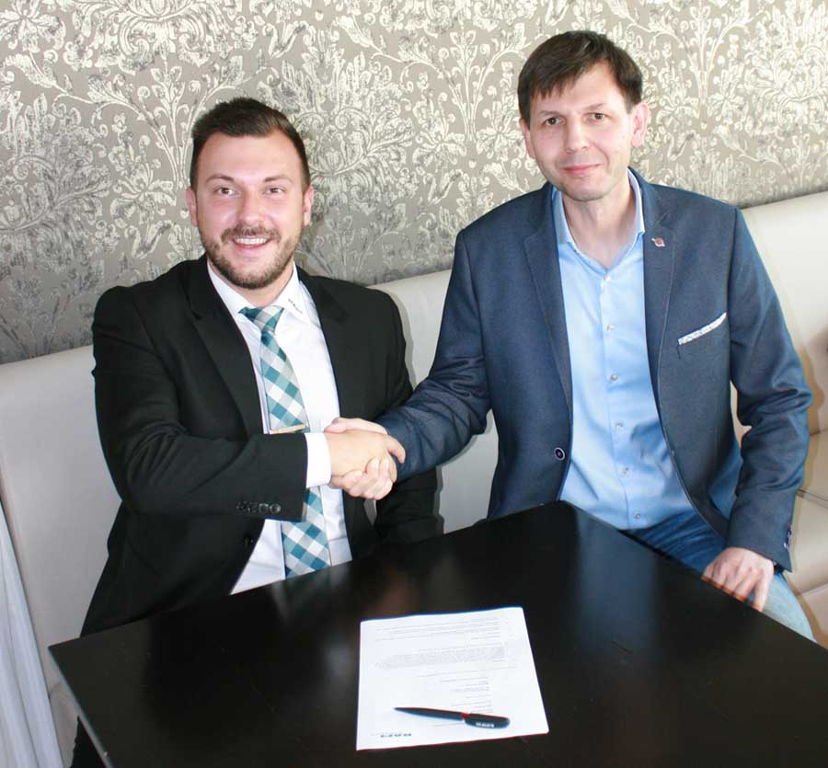
Illustration: Kai Zinnäcker (left) from the international sales team for RAFI's Business Unit Components and Donat Wachowiak, CEO of Wachowiak & Syn s.c., shake hands over their new partnership

Illustrations: | Vertriebspartner_Wachowiak&Syn | Char.s: | 682
File name: | 201808037_pm_sales_partner_poland_en | Date: | 09-19-2018
Company background RAFI group
Founded in 1900, RAFI now develops and produces electromechanical components such as pushbuttons and switches, operating systems such as touch screens, keyboards, electronic components, and systems for man-machine communication. RAFI products are employed in more than 30 industries, e.g., in medical equipment, mechanical engineering, road and railway vehicles, household appliances, and telecommunications. The RAFI group operates internationally with approx. 2,500 employees at ten sites in Germany, Europe, China, and the USA. The group’s headquarters are located in Berg (Baden-Württemberg, Germany).

Contact:  RAFI GmbH & Co. KG  Artur Krug  Ravensburger Str. 128-134  88276 Berg  Germany  Tel.: +49 . 751 . 891 307  Fax: +49 . 751 . 891 300  e-mail: artur.krug@rafi.de  WWW: www.rafi.de |  | gii die Presse-Agentur GmbH  Immanuelkirchstr. 12  10405 Berlin  Germany  Tel.: +49 . 30 . 5389 650  Fax: +49 . 30 . 5389 6529  email: info@gii.de  Internet: www.gii.de

