Press Release

Menzel Elektromotoren forms U.S. partnership

German motor manufacturer Menzel Elektromotoren has recruited an industry expert as a representative in the U.S. to serve customers even better: Marc Amato has 27 years of experience in the electric motor and machine industry, particularly in motor manufacturing, re-manufacturing, troubleshooting, and machine applications. He has led teams of engineers and technicians during installation, startup, and commissioning of machines up to 30,000 hp (20 MW). He has an in-depth background in forensic failure analysis and is a specialist in bearing systems. He is well connected in the power, cement, mining, steel industries, which are all focal sectors for Menzel. The manufacturer supplies the U.S. market with large special motors in the medium and high-output range and with smaller special motors such as roller table motors and crane motors. The company has a large stock of AC and DC motors for urgent replacements, and specializes in quickly adapting them for various applications as well as manufacturing bespoke motors from scratch. The portfolio includes DC motors up to 3,000 hp (2,000 kW) from 160 V to 1,000 V and induction motors from 220 V to 13,800 V: squirrel cage induction motors up to 33,000 hp (25,000 kW) and slip ring induction motors up to 20,000 hp (15,000 kW).
More information: https://www.menzel-motors.com/special-electric-motors/

U.S. sales contact:
Marc Amato
Phone: +1 401.640.7169
marca@menzel-motors.com

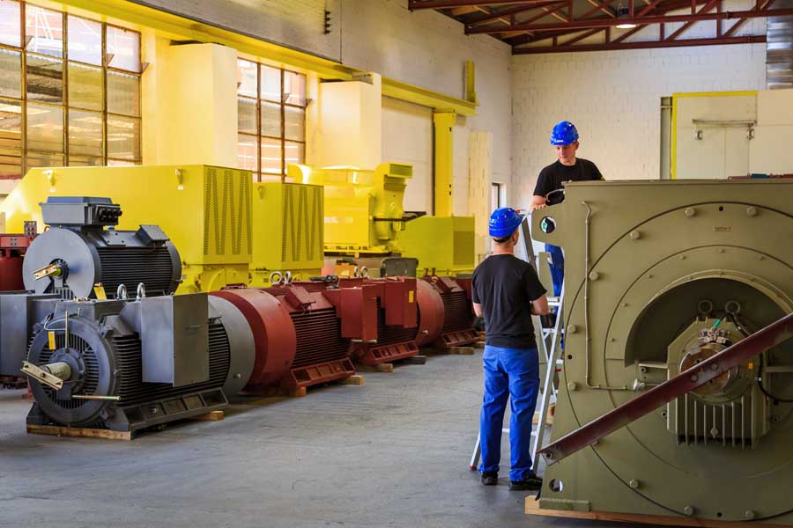
Caption: Menzel manufactures high-output special motors and can supply quick replacements from a large stock to keep downtimes down

Image/s: | menzel_large_electric_motors | Characters: | 1285
File name: | 202104023_pm_menzel_usa_en | Date: | 04-28-2021
About Menzel Elektromotoren
Based in Berlin, Menzel Elektromotoren GmbH has been manufacturing and distributing electric motors for more than 90 years. The medium-sized company specializes in the delivery of large electric motors, including special models, within the shortest possible time. The product range comprises high and low voltage motors, DC motors, transformers, and frequency inverters. Services include motor production and short-term adaptation of stocked motors to application-specific requirements. In order to ensure fast deliveries to the customer at all times, the company maintains a very extensive inventory including more than 20,000 motors with a maximum performance of up to 15,000 kW. Qualified engineering, experienced staff, and state-of-the-art production and testing facilities help Menzel provide excellent reliability. Menzel operates subsidiaries in the UK, France, Italy, Spain, and Sweden, and cooperates with numerous partners worldwide.

Contact:  Menzel Elektromotoren GmbH  Mathis Menzel  Neues Ufer 19-25  10553 Berlin  Germany  Phone: +49 . 30 . 349 922-0  Email: info@menzel-motors.com  Internet: www.menzel-motors.com | gii die Presse-Agentur GmbH  Immanuelkirchstr. 12  10405 Berlin  Germany  Phone: +49 . 30 . 538 965-0  Email: info@gii.de  Internet: www.gii.de

