Press Release

RAFI manufactures SmartTouch armrest for Valtra tractors

German electronics manufacturer RAFI worked in close cooperation with the Finnish tractor manufacturer Valtra to design SmartTouch armrests with a completely new multifunction drive lever for the new N, S, and T Valtra tractor series. The armrest integrates all of the components for controlling Valtra’s agricultural machinery. This innovative, highly ergonomic design won the 2017 Red Dot Design Award. The smart armrest is an integral part of Valtra's novel operating concept allowing drivers to customize the functionality of the controls in their cab.

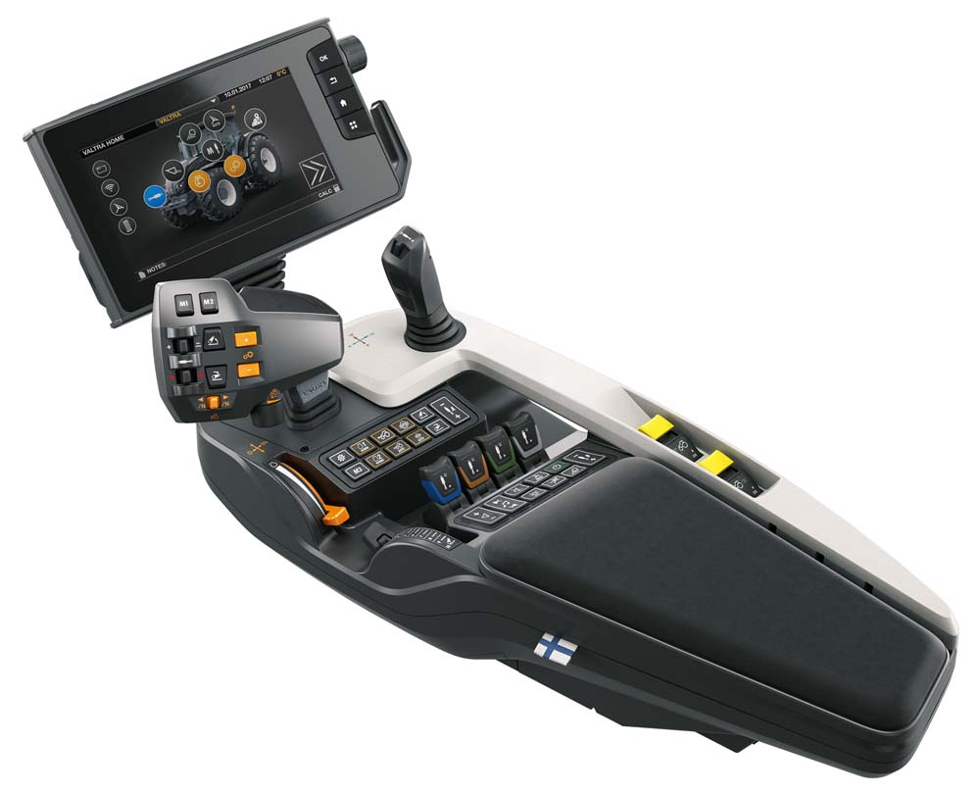
Illustration 1: RAFI and Valtra have developed new SmartTouch armrests with highly functional drive levers
(image: Valtra)

At the front end, the armrest features a touch screen with an interactive 3D representation of the tractor. Operators can select all vehicle functions by tapping on the model. They can set output ranges and numbers of revolutions via virtual slide controllers and, through a simple touch or swipe, assign functions to control elements according to their preferences. This includes the hydraulic system and all valves to operate front and rear loaders. Functions that are not needed can be disabled to prevent errors and ensure intuitive operation. All configurations are automatically saved and can be managed in any number of user profiles. RAFI manufactures the complete armrests including the housing and supplies them as ready-to-connect units with plug-and-play connectors. The multifunctional drive lever, the integrated thumb joystick, and the separate joystick for hydraulic control are based on RAFI's JOYSCAPE platform of customizable joysticks. RAFI designed form, function, and colors to Valtra's specifications. A handrest with an injection-molded soft rubber coating offers a comfortable, slip-proof hold. RAFI also integrated its own short-travel keyswitches and was thereby able to control the quality through in-house manufacturing. The drive lever and safely isolated sliders in the control panel are equipped with noncontact, wear-free Hall sensors with a service life that tests beyond five million operating cycles. These controls are used for continuous adjustment of the idle running mode and the rear loader. RAFI used short-travel keyswitches from its MICON 5 series for the membrane keyboard and pushbuttons and integrated redundant MICON variants for safety-critical functions. Furthermore, RAFI designed concave and convex bezels especially for Valtra. These enable easy haptic recognition of frequently used hard-key functions. "We do not impose a ready-made design on customers", says Eduard Janez, Global Key Account Manager at RAFI. "They are able to adapt the system to their needs and freely assemble the components. This enables our customers to realize their design ideas and develop intuitive ruggedized interface controls that improve the operator experience."

Illustration 2: Valtra T series tractors feature the new generation of armrests and a customizable operating concept
(image: Valtra)

Illustrations: | valtra_smarttouch  VALTRA_T-Serie_p | Char.s: | 2754
File name: | 201809039_pm_valtra_smarttouch_en | Date: | 20.02.2019
Company background RAFI group
Founded in 1900, RAFI now develops and produces electromechanical components such as pushbuttons and switches, operating systems such as touch screens, keyboards, electronic components, and systems for man-machine communication. RAFI products are employed in more than 30 industries, e.g., in medical equipment, mechanical engineering, road and railway vehicles, household appliances, and telecommunications. The RAFI group operates internationally with approx. 2,500 employees at ten sites in Germany, Europe, China, and the USA. The group’s headquarters are located in Berg (Baden-Württemberg, Germany).

Contact:  RAFI GmbH & Co. KG  Artur Krug  Ravensburger Str. 128-134  88276 Berg  Germany  Tel.: +49 . 751 . 891 307  Fax: +49 . 751 . 891 300  e-mail: artur.krug@rafi.de  WWW: www.rafi.de |  | gii die Presse-Agentur GmbH  Immanuelkirchstr. 12  10405 Berlin  Germany  Tel.: +49 . 30 . 5389 650  Fax: +49 . 30 . 5389 6529  email: info@gii.de  Internet: www.gii.de

