Press release

Customized ultrasonic angle sensors

With a new model variant of the proven sensor series P47, PiL Sensoren GmbH underlines its flexibility in the development of customized special solutions. The high-precision ultrasonic sensors are predestined for basic applications such as distance and level measurements in the measuring range up to 5,000mm and ensure reliable detection of even small objects due to their sound intensity. For demanding industrial applications with limited installation space, PiL has now produced a special version of the sensor for distances from 50mm to 500mm at the request of a customer. Instead of the conventional plastic housing, this sensor variant is equipped with a robust M18 stainless steel housing as well as a 90° deflection angle and complete shielding. The manufacturer offers the ultra sonic device optionally with fixed or customized characteristic curve. The stainless steel distance sensor features a fast response time of 60ms, temperature compensation and a synchronization function for up to ten sensors, which is realized by connecting the HLD/Sync inputs. With the reflector angle screwed on, a significant reduction in the blind zone can be achieved in addition to sound redirection. The new stainless steel version, EMC-shielded according to IEC 61326-2-1 and IEC 61326-2-3, complies with protection class IP65 and withstands operating temperatures from 20°C to +70°C. The sensor head must be protected from direct contact with hot water above 50°C or steam.

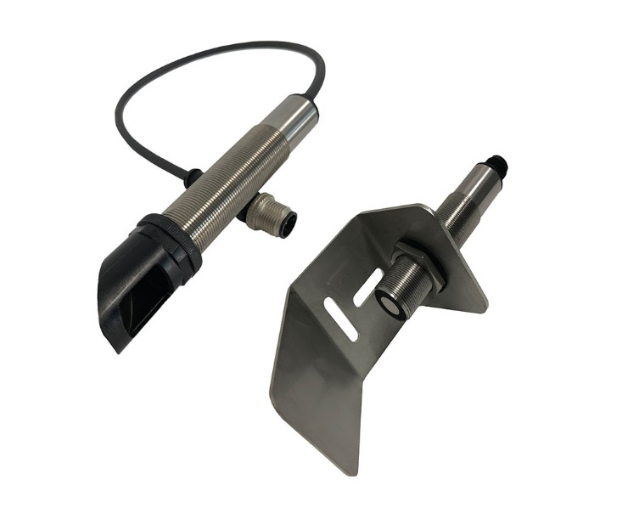
Image: New customized P47 sensor variant from PiL for ultrasonic level and distance measurement in robust stainless steel housing with optional deflection angle

PiL offers comprehensive application know-how and responds flexibly to customer requirements at all times. And where application-specific parameterization is not sufficient, the manufacturer is also happy to support its customers on request with individually customized solutions. The development and manufacturing facilities of the specialist for industrial ultrasonic sensor technology are in Germany.

Image/s: | winkelsensor_p47_2000px.jpg | Characters: | 1,471
File name: | 202301009_pm_p47_ultrasonicsensor.docx | Date: | 01-17-2023
About PIL
PiL Sensoren GmbH, with its headquarters in Erlensee near Frankfurt/Main is a pioneer of ultrasonic technology and has been developing, producing, and selling standard and customized sensor solutions for industrial applications since 1990. Together with Inelta Sensorsystem GmbH & Co. KG (Taufkirchen near Munich) and VYPRO s.r.o. (Trenčín, Slovakia), PiL offers a wide range of products for measuring displacement and position as well as force, pressure, and inclination. The range of products we offer includes force sensors, sensor signal amplifiers, pressure switches, capacitive sensors, and ultrasonic sensors. Our portfolio is nicely rounded off with cable and connector assembly services.
Most of the group of companies’ customers are in industrial automation, mechanical engineering, hydraulics, medical technology as well as the aerospace industry. We especially focus on industry and customer-specific sensor solutions and are constantly expanding this focus with interdisciplinary know-how.
Contact:  PIL Sensoren GmbH  Zweigstelle Süd  Reinhard Koch  Ludwig-Boelkow-Allee 22  82024 Taufkirchen  Germany  Phone: +49 89 / 452 245-0  Fax: +49 89 / 452 245-744  Email: marketing@pil.de  Internet: www.pil.de |  | gii die Presse-Agentur GmbH  Immanuelkirchstr. 12  10405 Berlin  Germany  Phone: +49 30 / 538 965-0  Email: info@gii.de  Internet: www.gii.de

