Press Release

Motors for swift shipping

Menzel Elektromotoren has modified, tested, and delivered two 2400-kW motors for the fast RoPax ferry MV Ulysses meeting extremely tight deadlines of two and three weeks. Operated by Irish Ferries, Ulysses is one of the largest ferries in the world servicing the busy Dublin—Holyhead route. It has 12 decks for up to 2000 passengers and 1340 cars or 240 trucks. The operator urgently needed new motors for two of the four azimuth thrusters – propellers used for sideways maneuvering in ports. One of the German motor builder's experienced service staff took measurements on site in order to adhere to tight refit specifications and timelines, and to avoid the kind of installation difficulties caused by earlier replacement motors. Menzel adapted two squirrel-cage motors from their large inventory of motors and components for many common applications. The selected motors are by default suitable for high humidity environments. Menzel provided them with IP54 protection for maritime application and made numerous additional adjustments in the shortest possible time.

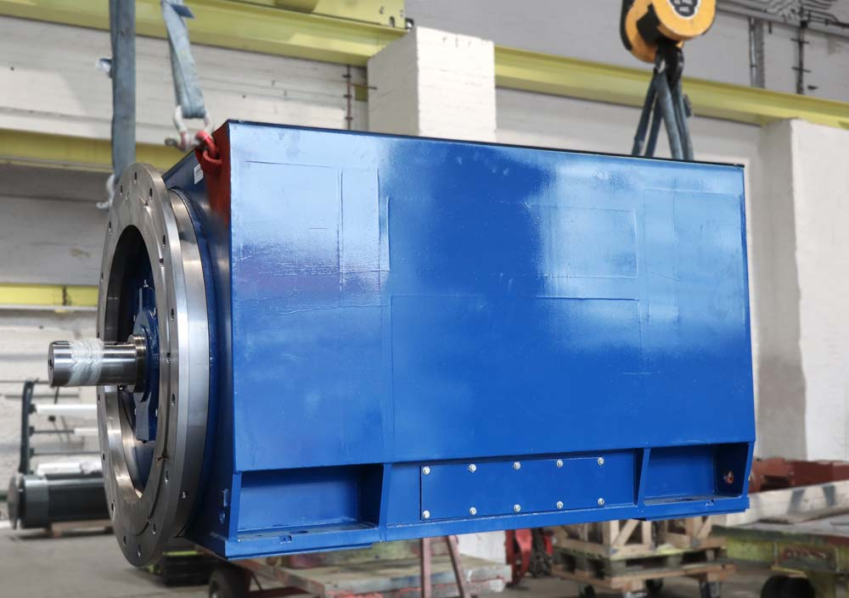
Caption: Menzel offers customers a level of service that is probably unique in the market, delivering heavy-duty motors in no time at all

The team converted the stock motors from horizontal to vertical operation, modifying the bearings accordingly, installing new thrust bearings, and producing a special vertical-mounting flange. They dismantled and re-configured the fan design in order to change the rotational direction. They shortened the shafts and machined them for smaller diameters. To meet the vessel’s mechanical interfaces, the terminal boxes had to be installed in exactly the right position; even the arrangement of the terminal studs was predetermined. The customer provided the water coolers, whilst Menzel modified the stator frames to connect the coolers, implementing cooling type IC 81W. Ultimately, the manufacturer tested the motors in their own load test field, with the customer present on site in Berlin for the final inspection. Menzel completed both motors on time, thus once again proving themselves to be an exceptionally flexible supplier.
More information about modular squirrel-cage motors with a wide range of design options is available at https://www.menzel-motors.com/squirrel-cage-motor/ic81w-ic86w/.

Image/s: | mebksw_ulysses_ferrry | Characters: | 2166
File name: | 202003028_pm_car_ferry_ireland_en | Date: | 03-18-2020
About Menzel Elektromotoren
Based in Berlin, Menzel Elektromotoren GmbH has been manufacturing and distributing electric motors for more than 90 years. The medium-sized company specializes in the delivery of large electric motors, including special models, within the shortest possible time. The product range comprises high and low voltage motors, DC motors, transformers, and frequency inverters. Services include motor production and short-term adaptation of stocked motors to application-specific requirements. In order to ensure fast deliveries to the customer at all times, the company maintains a very extensive inventory including more than 20,000 motors with a maximum performance of up to 15,000 kW. Qualified engineering, experienced staff, and state-of-the-art production and testing facilities help Menzel provide excellent reliability. Menzel operates subsidiaries in the UK, France, Italy, Spain, and Sweden, and cooperates with numerous partners worldwide.

Contact:  Menzel Elektromotoren GmbH  Mathis Menzel  Neues Ufer 19-25  10553 Berlin  Germany  Phone: +49 . 30 . 349 922-0  Email: info@menzel-motors.com  Internet: www.menzel-motors.com | gii die Presse-Agentur GmbH  Immanuelkirchstr. 12  10405 Berlin  Germany  Phone: +49 . 30 . 538 965-0  Email: info@gii.de  Internet: www.gii.de

