Press Release

Rugged protective enclosure for FLIR AX8 thermal imaging camera

autoVimation has expanded its Chameleon series of protective camera enclosures, adding a model for the FLIR AX8 thermal imaging camera. The germanium and BK7 glass windows are perfectly aligned with the FLIR AX8 imagers to allow simultaneous operation of the infrared camera, visual camera and LED lighting. The rugged aluminum enclosure with protection class IP66/IP67 is designed for long-term use in demanding industrial environments with high humidity levels. In order to compensate for thermal expansion and vibrations, autoVimation does not glue the germanium and BK7 lenses, but fits them with a special sealing system. Under normal ambient conditions, the enclosure requires no internal cooling as the solid camera mounting plate ensures reliable heat dissipation. The manufacturer provides extensive accessories including a wide range of brackets and mounting kits for precise angled orientation. An optional dovetail profile on the back of the protective enclosure ensures heavy-duty, vibration-proof connection to the brackets. The enclosure measures 175 mm x 80 mm x 57 mm without cable gland.

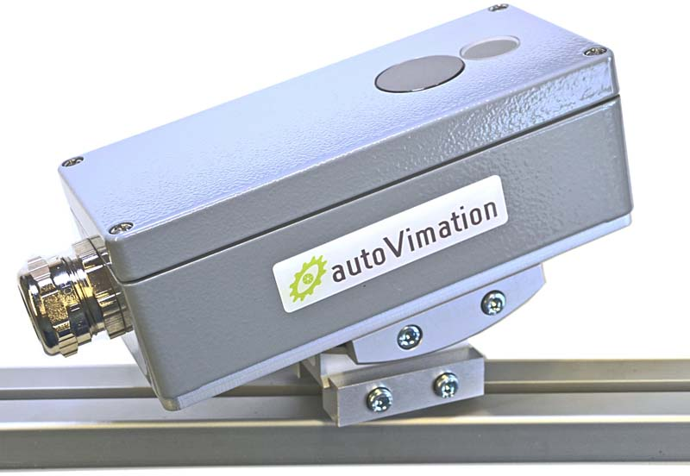
Caption: The new protective Chameleon enclosure for FLIR AX8 enables simultaneous operation of infrared camera, visual camera and LED lighting

Image/s: | Chamaeleon_fuer_FLIR_AX8 |  | Characters: | 1105
File name: | 202209023_pm_chameleon_enclosure_flir_ax8_en |  | Date: | 12-07-2022
About autoVimation
The German manufacturer autoVimation was founded in 2008 by Peter Neuhaus to provide solutions for easier installation and adjustment of image processing components. The company has developed a modular construction kit that simplifies the connection of all required components, which does away with costly and time-consuming manufacturing of dedicated mounting brackets. The product portfolio also includes compact, easy-to-integrate enclosures that provide optimal protection for cameras and lenses in industrial applications, and ensure good heat dissipation. autoVimation supplies complete, ready-to-install mechanical solutions for cameras and light fittings, and enables the integration of special lenses, filters, light barriers, encoders, or other sensors.
autoVimation's customers include renowned companies from various industry branches, such as the pharmaceutical and food industry, measuring technology, quality control, and security technology.
Contact:  autoVimation GmbH  Peter Neuhaus  Roemerweg 1  76287 Rheinstetten  Germany  Phone: +49 . 721 . 627 6756  Email: sales@autovimation.com  Internet: www.autovimation.com |  | gii die Presse-Agentur GmbH  Immanuelkirchstr. 12  10405 Berlin  Germany  Phone: +49 . 30 . 538 9650  Email: info@gii.de  Internet: www.gii.de

