Press Release

Acoustic imagers at UK tradeshows Hydrogen Tech Expo and Plant & Asset Management

Fluke will present its versatile portable and fixed acoustic imaging solutions at two UK tradeshows in March and April: Hydrogen Tech Expo at Telford International Centre and Plant & Asset Management at NEC Birmingham.
The SV600 Fixed Acoustic Imager from Fluke Process Instruments enables users to detect, locate, and visualize air and gas leaks or changes in sound signatures across their process and equipment in real-time before they become costly problems. The handheld Fluke ii900 Industrial Acoustic Imager visualizes the sounds coming from small leaks in compressed air, gas, and vacuum systems, as part of routine inspections, and helps customers drive greater energy efficiencies.
Using an array of sophisticated sound sensors, a camera and powerful SoundMap technology, the SV600 and ii900 series visualize sounds for asset monitoring, troubleshooting and quality inspection for manufactured products that are tested for air leaks. The SV600 easily integrates with factory systems and enables 24/7 monitoring of compressors, pumps, pipes and other equipment with user-defined alarms. Remote evaluation options help minimize operator intervention, even in parts of the facility that are hard to reach – notably the SV600 has already been integrated, as a payload, in the Boston Dynamics agile robot Spot for surveillance in difficult-to-access or potentially unsafe environments.

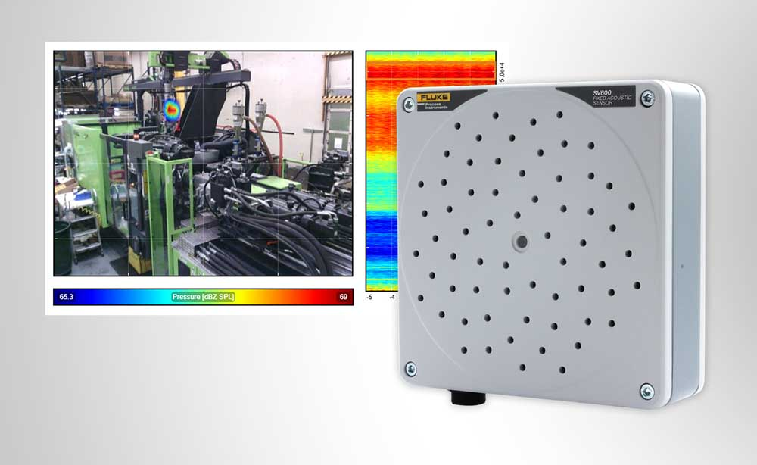
Caption 1: The SV600 Fixed Acoustic Imager detects and locates gas leaks and mechanical faults

Fluke Process Instruments also provides a comprehensive range of rugged infrared temperature measurement and thermal imaging solutions as well as Datapaq thermal profiling systems and will be happy to advise tradeshow visitors regarding their individual measurement tasks. Various dedicated hardware and software solutions are available for all kinds of industrial applications, including customized implementations.

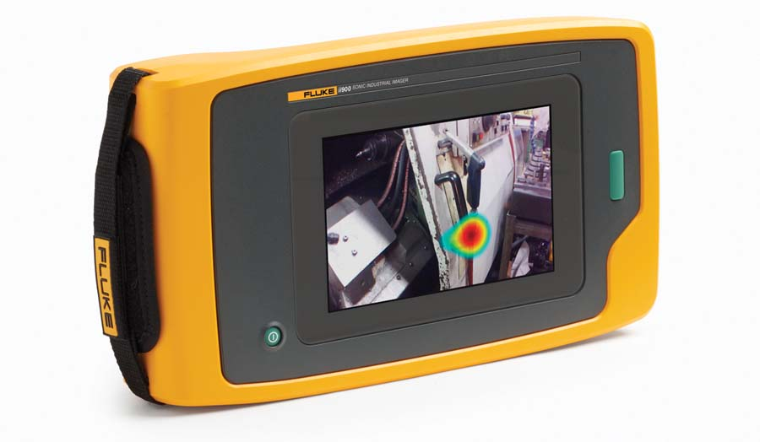
Caption 2: The Fluke ii900 Industrial Acoustic Imager provides a flexible handheld solution for detecting gas leaks

Image/s: | sv600_fixed_acoustic_imager  fluke_ii900_industrial_acoustic_imager | Characters: | 1803
File name: | 202203017_pm_sv600_uk_tradeshows_en | Date: | 03-28-2022
About Fluke Process Instruments
Fluke Process Instruments designs, manufactures, and markets a complete line of infrared temperature measurement and profiling solutions for industrial, maintenance, and quality control applications. Distributed worldwide under the Raytek, Ircon, and Datapaq brands, the products reflect the combined experience of over 150 years in manufacturing the world’s finest temperature measurement tools and devices.
About Fluke
Founded in 1948, Fluke Corporation is the world leader in compact, professional electronic test tools. Fluke customers are technicians, engineers, electricians, and metrologists who install, troubleshoot, and manage industrial, electrical, and electronic equipment and calibration processes.
Contact:  Fluke Process Instruments GmbH  Blankenburger Str. 135  13127 Berlin  Germany  Phone: +49 . 30 . 478 008-0  Email: marketing@flukeprocessinstruments.de  Internet: www.flukeprocessinstruments.com |  | gii die Presse-Agentur GmbH  Immanuelkirchstr. 12  10405 Berlin  Germany  Phone: +49 . 30 . 538 9650  Email: info@gii.de  Internet: www.gii.de

