Press Release

Patented contact-protected connection for multimeter supply

Gossen Metrawatt has introduced a new patented solution for secure power supply of its DAkkS-calibrated digital multimeters METRAHIT IM XTRA and METRAHIT IM E-DRIVE. The portable all-in-one devices integrate an exceptionally wide range of testing and measuring functions for maintenance, service and diagnosis of electrical machines, drives and systems. In addition, they also cover measuring methods for safety testing in the automotive industry, avionics and electrical engineering. Gossen Metrawatt has now patented its innovation of a contact-protected connection of the quickly exchangeable supply modules for mains or battery operation. The terminal is recessed into the housing body, effectively ensuring device safety according to CAT III or CAT IV at all times even when exchanging modules or batteries during operation. This solution ensures protection against electric shock according to measuring category 1,000V CAT III, even at overvoltages up to 6,000V. Users can also safely exchange the supply module when the measurement cables are plugged in and the measuring signal is applied, and that without having to disconnect the measurement cables from the test object. Spring-loaded contacts and an extended-length connector format ensure reliable contacting inside the housing. The new patented solution, which is registered by the European Patent Office under publication number EP3474023A2, underlines Gossen Metrawatt’s high innovative capacity in the field of measurement and test technology for electrical safety.

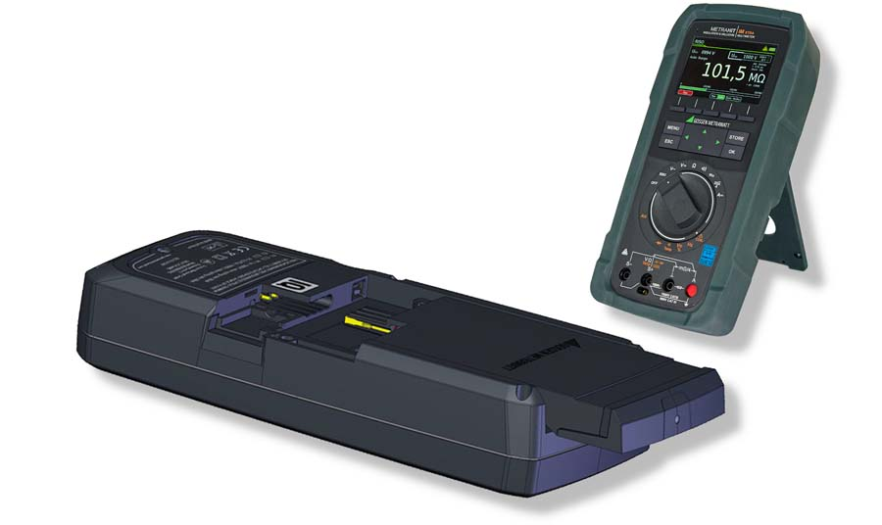
Caption: Battery and mains power supply module for METRAHIT IM multimeter with patented contact-protected connection

Image/s: | versorgungsmodul | Characters: | 1531
File name: | 202106019_pm_patented_metrahit_connection_en | Date: | 06-30-2021
About Gossen Metrawatt
Gossen Metrawatt, one of the world’s leading suppliers of measurement systems, develops and distributes a wide range of high-quality measuring and test devices for electrical trade, various industries and the public sector.
The Gossen Metrawatt brand has been synonymous with safety and quality “Made in Germany” for decades. Its product range includes measurement and test technology for the electrical safety of plants, devices and machines as well as for the e-mobility and medical technology industries. Additional key areas of interest are power quality, battery testing technology, multimeters, calibrators, power supply technology and energy management systems. For a truly comprehensive electrical safety portfolio, Gossen Metrawatt also offers a continuously growing range of digital services and cloud services and supports its customers with a versatile training program and a wide range of after-sales services.
Gossen Metrawatt is part of the GMC Instruments Group, which also includes other specialized manufacturers for measurement and testing technology – notably, Camille Bauer Metrawatt, Dranetz, Prosys, Seaward and Rigel and Kurth Electronic. The Camille Bauer and Rigel brands add to the portfolio various transducers, display instruments and detection systems for heavy-current engineering as well as special measuring, testing and functional testing devices for the medical sector. The GMC-I Group runs its own DAkkS-certified calibration center that performs DAkkS, ISO and factory calibrations for virtually all electrical measured quantities. The GMC-I Group has development and production sites in Germany, Switzerland, England and the USA and a worldwide sales network of its own companies as well as sales partners.

Contact:  Gossen Metrawatt GmbH  Christian Widder  Head of Marketing Communication  Suedwestpark 15  90449 Nuremberg  Germany  Phone: +49 . 911 . 8602-572  Email: christian.widder@gossenmetrawatt.com  Internet: www.gossenmetrawatt.com | gii die Presse-Agentur GmbH  Immanuelkirchstr. 12  10405 Berlin  Germany  Phone: +49 . 30 . 538 9650  Email: info@gii.de  Internet: www.gii.de

