Press Release

Fluke Process Instruments MP Linescanner Series speeds non-contact temperature imaging and analysis
New line of industrial scanners delivers real-time thermal imaging at scan speeds up to 300 Hz

Fluke® Process Instruments, a global leader in infrared temperature measurement and thermal profiling solutions for industrial applications, introduces the MP Linescanner Series, which delivers continuous, accurate, edge-to-edge thermal images and temperature measurements for high-speed manufacturing processes. The series features Fluke’s widest selection of spectral and temperature ranges to accommodate a variety of industrial applications. The new imagers provide real-time imaging at scan speeds up to 150 or even 300 Hz: three shortwave models deliver maximum scan rates of 300 lines per second; these are geared primarily at the metals industry.
“Scan rate is essential for rapid detection of temperature anomalies, such as non-uniformities and hotspots,” said Dr. Martin Budweg, Global Product Manager, Fluke Product Instruments. “The new MP Linescanners can measure up to 1024 temperature points across a scan line at a rate of up to 300 lines per second, allowing manufacturers to better control their continuous moving processes, automate temperature measurements, and ensure product quality.”
The versatile MP Linescanner Series features rotating optics and a 90-degree field of view that quickly renders a 2D image on a PC. Additional key features include:
- High-quality brushless motor (MTBF 40,000 h)
- Built-in Ethernet TCP/IP communications
- PC-independent alarm output
- PC-independent 4 – 20 mA interfaces (3 outputs)
- I/O module support for up to 10 sectors/zones (PC-independent)
- Internal line laser for accurate alignment
- Rugged, waterproof IP65 enclosure
- Air purge to keep the window free of dirt and condensation
- Built-in water cooling for ambient up to 180 °C (356 °F)

DataTemp DP Software provides real-time monitoring and remote configurations

The MP Linescanner Series can be used in standalone mode, connected to a single PC, or integrated into a comprehensive process control system by using the DataTemp® DP Software. This industrial Windows-based software package provides remote configurations of the imager and real-time process monitoring. The DataTemp DP Software supports multiple product-specific configurations (recipes), text file alarm logging, and fail-safe alarm logging. It features the ability to support multiple linescanners and real-time ambient temperature compensation/emissivity adjustments.
Fluke Process Instruments offers numerous customized process imaging systems to meet the specific application requirements for processes like glass processing, extrusion coating, thermoforming machine control, kiln shell monitoring, and gypsum wallboard production. Each customized system features application-specific software to help ensure product quality, quality improvements, reduced rework rates and more.
More information: https://lp.flukeprocessinstruments.com/mp300/ien/

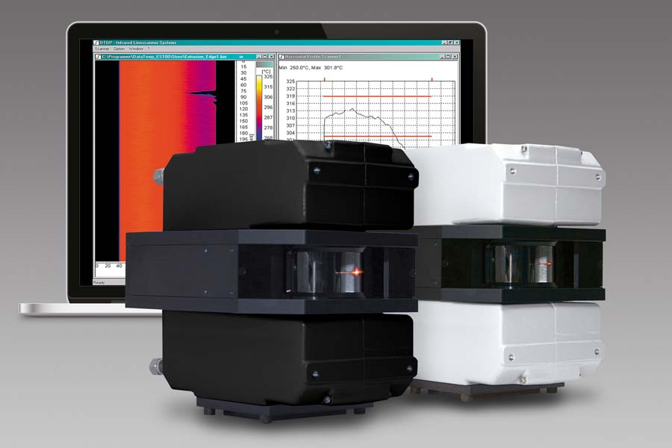
Caption: The new infrared linescanners provide real-time thermal imaging at up to 300 Hz in various industry applications

Image/s: | mp_linescanner | Characters: | 2754
File name: | 202103039_pm_mp300_linescanner_en | Date: | 04-22-2021
About Fluke Process Instruments
Fluke Process Instruments designs, manufactures, and markets a complete line of infrared temperature measurement and profiling solutions for industrial, maintenance, and quality control applications. Distributed worldwide under the Raytek, Ircon, and Datapaq brands, the products reflect the combined experience of over 150 years in manufacturing the world’s finest temperature measurement tools and devices.
About Fluke
Founded in 1948, Fluke Corporation is the world leader in compact, professional electronic test tools. Fluke customers are technicians, engineers, electricians, and metrologists who install, troubleshoot, and manage industrial, electrical, and electronic equipment and calibration processes.

Contact:  Fluke Process Instruments GmbH  Blankenburger Str. 135  13127 Berlin  Germany  Phone: +49 . 30 . 478 008-0  Email: marketing@flukeprocessinstruments.de  Internet: www.flukeprocessinstruments.com | gii die Presse-Agentur GmbH  Immanuelkirchstr. 12  10405 Berlin  Germany  Phone: +49 . 30 . 538 965-0  Email: info@gii.de  Internet: www.gii.de

