Press Release

ECHT Antwerp: Temperature detection for heavy metal

Fluke Process Instruments will exhibit temperature sensing solutions at the European Conference on Heat Treatment in Antwerp, Belgium. The manufacturer develops both infrared sensors for continuous remote monitoring of equipment and processes and datalogging systems for furnace surveys and in-process product temperature profiling. Designed to meet today’s demanding industrial automation requirements, the hardware and software systems allow operators to optimize their processes for consistent high quality and fuel efficiency. An exhibition highlight, the ThermoView TV40 industrial-grade thermal imager with an integrated visible-light camera, enables 24/7 temperature monitoring in a -10 °C to 1200 °C range. Target applications include iron foundries where the imagers check temperatures of molten metal and monitor ladles to ensure that the refractory lining is intact. Users can define various areas of interest with distinct alarm conditions. Also on show, the Datapaq Furnace Tracker performs temperature uniformity surveys (TUS) and system accuracy tests (SAT) compliant with NADCAP AMS 2750E and CQI-9. This system is based on the Datapaq TP3 data logger with up to 20 measurement channels. It is designed to travel through heat-treatment and quench processes. Datapaq thermal profilers include analysis and reporting software, thermocouples, and thermal barriers. The team will be happy to advise visitors on the best way to tackle their particular measurement needs.
ECHT European Conference on Heat Treatment
Antwerp, Belgium, 25 – 27 March 2020

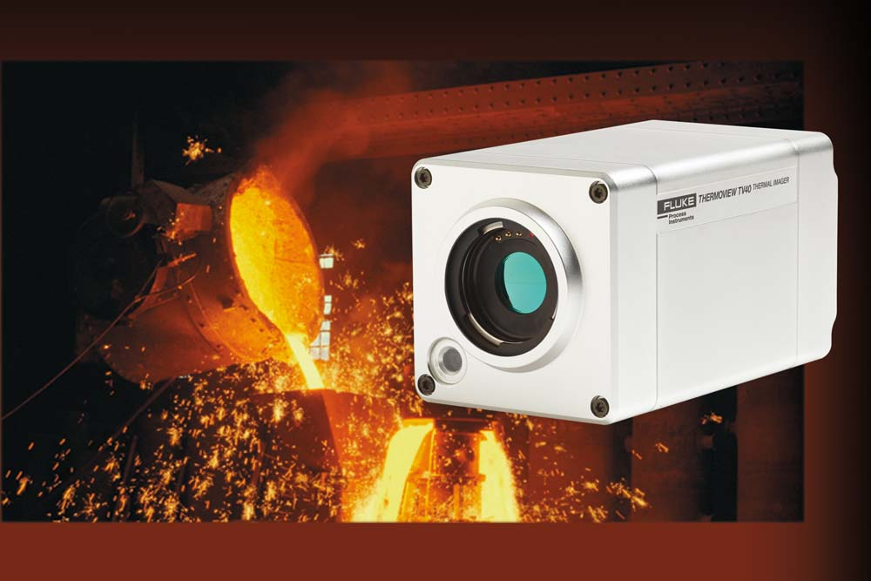
Caption 1: Thermal imagers detect hotspots and help operators avoid costly damage and unscheduled downtime

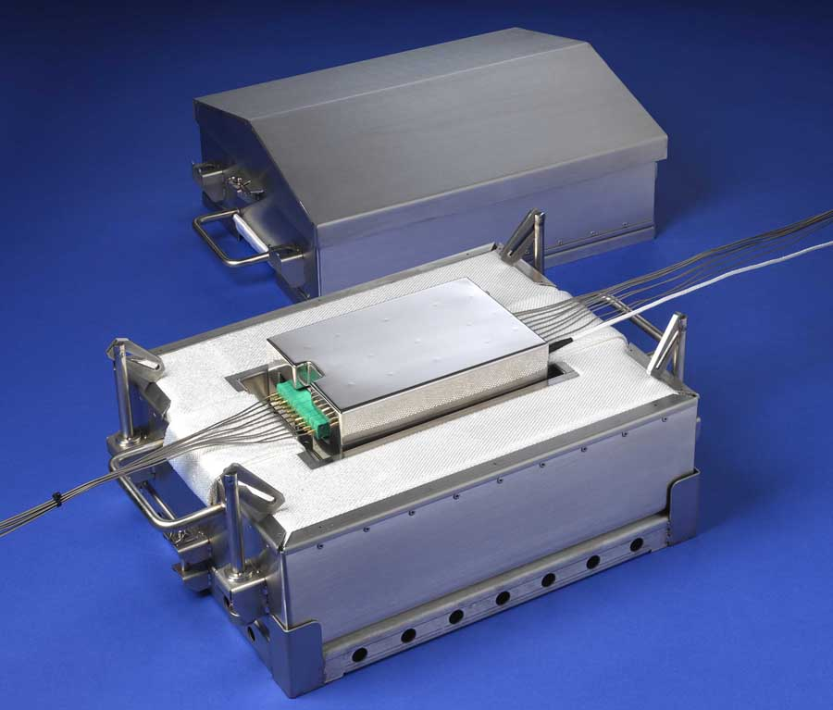
Caption 2: Furnace Tracker systems enable in-process temperature profiling with up to 20 thermocouples

Image/s: | thermoview_tv40_iron_foundry_ladle  datapaq_tp3__heat_sink__tb | Characters: | 1481
File name: | 202002008_pm_echt_antwerp_en | Date: | 02-12-2020
About Fluke Process Instruments
Fluke Process Instruments designs, manufactures, and markets a complete line of infrared temperature measurement and profiling solutions for industrial, maintenance, and quality control applications. Distributed worldwide under the Raytek, Ircon, and Datapaq brands, the products reflect the combined experience of over 125 years in manufacturing the world’s finest temperature measurement tools and devices.
About Fluke
Founded in 1948, Fluke Corporation is the world leader in compact, professional electronic test tools. Fluke customers are technicians, engineers, electricians, and metrologists who install, troubleshoot, and manage industrial, electrical, and electronic equipment and calibration processes.

Contact:  Fluke Process Instruments GmbH  Leonardo Trame  Blankenburger Str. 135  13127 Berlin  Germany  Phone: +49 . 30 . 478 008-0  Email: marketing@flukeprocessinstruments.de  Internet: www.flukeprocessinstruments.com | gii die Presse-Agentur GmbH  Immanuelkirchstr. 12  10405 Berlin  Germany  Phone: +49 . 30 . 538 965-0  Email: info@gii.de  Internet: www.gii.de

