Press Release

Sealing elements for maximized cable packing density

Developing the KDS-DES sealing elements for unassembled cables, CONTA-CLIP has transferred the simple cable entry principle of its KES system to its KDS cable feedthrough system: to insert a cable, the membrane of this, newest sealing element is first pierced at the marked center, whereupon the cable can be pushed through the selected channel. The design based on the proven KES system ensures reliable sealing according to the degree of protection IP54. The KDS-DES variants currently available accommodate up to eight cables, depending on the cable diameter, which can range between 4.5 mm and 10.5 mm. Despite the high packing density, KDS-DES sealing elements are compatible with almost all KDS solutions. Like those, they are pressed into the frame openings for installation from the inside. Their conical shape allows for easy insertion and reliable sealing of gaps.

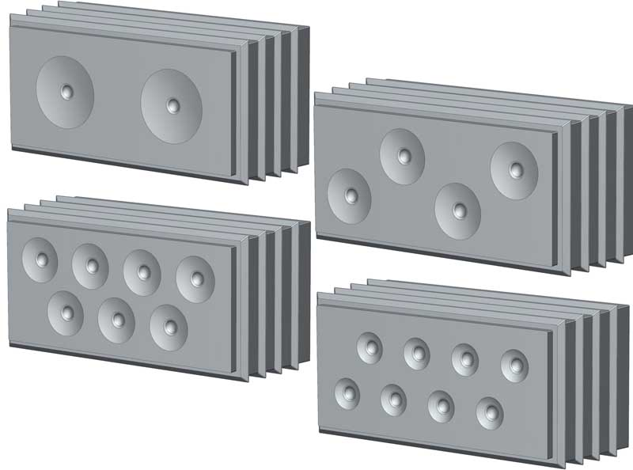
Caption: KDS-DES sealing elements for CONTA-CLIP cable entry systems provide IP54 ingress protection

Image/s: | KES-DES_Bsp | Characters: | 874
File name: | 201912015_pm_kds-des_sealing_elements_en | Date: | 03-11-2020
About CONTA-CLIP
CONTA-CLIP is one of Europe’s leading manufacturers of electrical and electronic connection elements and cable management solutions. Based in Hövelhof, Germany, the medium-sized, family-run company has been producing electric and electronic connection systems for the process and automation industries for 40 years. CONTA-CLIP supplies all industry sectors, focusing on railroad industries, shipbuilding, building automation, conveyor technology, machine and plant engineering and construction, instrumentation and control technology, control panel manufacturing, transformer manufacturing, and environmental technology. The company consists of many specialized branches: CONTA-CONNECT for electric connection technology, CONTA-CABLE for cable management systems, CONTA-ELECTRONICS for electronics and CONTA-CON for PCB edge connectors. Additionally, CONTA-CLIP provides services such as customizing housings and mounting rails, labeling and supplying user-specific electronic components.

Contact:  CONTA-CLIP  Verbindungstechnik GmbH  Christian Quade  Otto-Hahn-Str. 7  33161 Hövelhof  Germany  Phone: +49 . 5257 . 9833 - 0  Fax: +49 . 5257 . 9833 - 33  Email: christian.quade@conta-clip.de  Internet: www.conta-clip.com | gii die Presse-Agentur GmbH  Immanuelkirchstr. 12  10405 Berlin  Germany  Phone: +49 . 30 . 538 965 - 0  Fax: +49 . 30 . 538 965 - 29  Email: info@gii.de  Internet: www.gii.de

