Press Release

Large slip ring motor quickly customized

Menzel Elektromotoren has adapted and delivered a 6500-kW slip ring motor for a cement mill at short notice. The MEBSSL-type motor is ideally suited for industrial applications with high starting torques. Menzel adapted the internal motor winding connections for a 60-Hz mains voltage in the country of operation, Canada, and moved the terminal box according to customer specifications. The capability to provide such a flexible, on-schedule customization was decisive for winning the contract. The motor design moreover ensures long-term reliable operation in the target application. The motor series is characterized by high efficiency, high power density, a compact design, robust bearings and high load capacity. The welded-steel housing is designed for maximum torsional rigidity and optimal cooling. The motor features protection class IP55, cooling class IC 611 and a nominal torque of 52076 Nm. The enclosed self-cooling system, a detached air-to-air heat exchanger, ensures high efficiency and optimal dust protection. Slip ring motors are still the preferred choice of many cement plant operators. In dusty environments, they offer great advantages over the combination of squirrel-cage motors and frequency inverters because they need no power electronics and are therefore much more resilient. Not least, there is a considerable price difference in this performance class. Three-phase slip ring motors, which are started with a liquid starter, offer an economic solution for driving mills, crushers and conveyors. They only require small starting currents and provide the full torque from standstill.
More about modular slip ring motors up to 8000 kW: https://www.menzel-motors.com/slip-ring-motor/ic611-ic616-ic666/

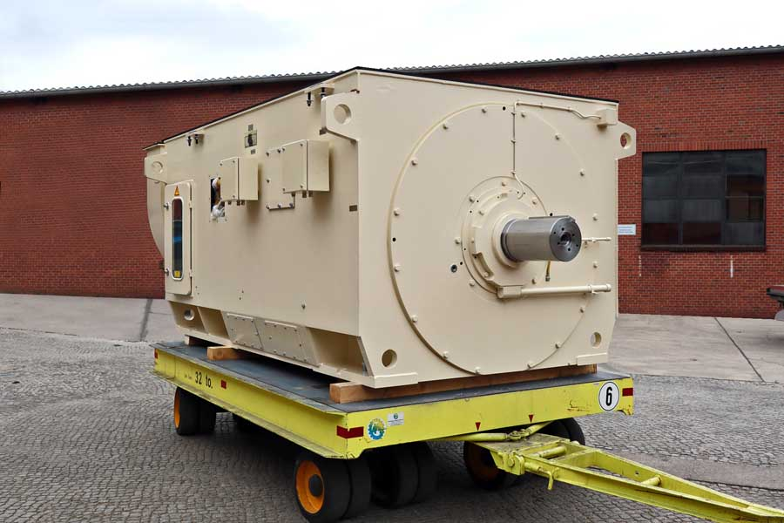
Caption: German motor manufacturer Menzel adapted the slip ring motor from its modular MEBSSL series to customer specifications at short notice

Image/s: | cement_mill_motor_canada | Characters: | 1612
File name: | 2022-06-11_4_cement_mill_motor_en | Date: | 06-10-2022
About Menzel Elektromotoren
Based in Berlin, Menzel Elektromotoren GmbH has been manufacturing and distributing electric motors since 1927. The medium-sized company specializes in the delivery of large electric motors, including special models, within the shortest possible time. The product range comprises high and low voltage motors, DC motors, transformers, and frequency inverters. Services include motor production and short-term adaptation of stocked motors to application-specific requirements. In order to ensure fast deliveries to the customer at all times, the company maintains a very extensive inventory including more than 20,000 motors with a maximum performance of up to 15,000 kW. Qualified engineering, experienced staff, and state-of-the-art production and testing facilities help Menzel provide excellent reliability. Menzel operates subsidiaries in the UK, France, Italy, Spain, and Sweden, and cooperates with numerous partners worldwide.
Contact:  Menzel Elektromotoren GmbH  Mathis Menzel  Neues Ufer 19 – 25  10553 Berlin  Germany  Phone: +49 . 30 . 349 922-0  Email: info@menzel-motors.com  Internet: www.menzel-motors.com |  | gii die Presse-Agentur GmbH  Immanuelkirchstr. 12  10405 Berlin  Germany  Phone: +49 . 30 . 538 9650  Email: info@gii.de  Internet: www.gii.de

