Press Release

RAFI Group invests in the future

RAFI is currently investing in two major projects: In April 2023, the company will begin construction of a new building in Bad Waldsee with infrastructure that is both energy-efficient and low-consumption. The new facility is a combined, state-of-the-art office and production building. It will house the operating equipment for plastics and automatic machine production, metal processing, tool and die making, and tool and die development. A number of classrooms and the facilities for basic training in metalwork will be combined into an impressive apprenticeship, teaching, and further training center. “These projects represent an investment in the sustained further growth of the entire RAFI Group,” explains Dr. Lothar Seybold, CEO of the RAFI Group. CFO Lothar Arnold adds: “The construction of a new production plant in Bad Waldsee is a clear statement of commitment to the region as a business location. It creates new, crisis-proof jobs here.”

The second major project is the revamp of the location in Berg. It was launched in 2022 and RAFI has now completed the first construction phase. As part of its growth strategy, RAFI is investing a sum in the high two-digit millions for the three-year renovation and energy-saving modernization project. It involves successively fitting the buildings with new, climate-friendly roofs, façades, and glazing. The physical effects are expected to deliver energy savings of up to 45% and a significant reduction in CO₂ emissions of around 340 tons per year. The first construction phase for Building A has been successfully completed. Now the nine-story block has new external insulation plus a rear-ventilated façade made of certified recycled aluminum. From an energy standpoint, all components are designed for maximum reduction in CO₂ emissions.

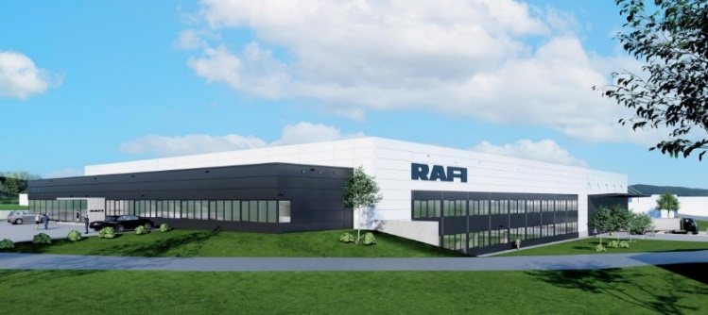
Caption 1: In April 2023 RAFI will start construction of a state-of-the-art office and production facility in Bad Waldsee

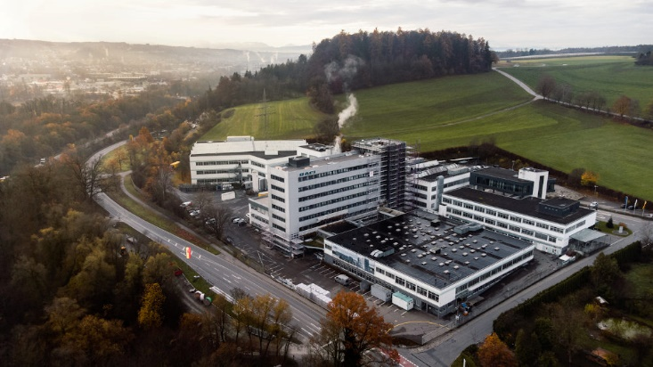
Caption 2: The RAFI modernization project in Berg includes an upgrade of Building A with new external insulation and rear-ventilated metal façade

Image/s: | bad_waldsee-rendering.jpg  berg-gesamtansicht.jpg | Characters: | 1.798
File name: | 202302020_pm_modernisierung_en.docx | Date: | 02-22-2023

About the RAFI group
Founded in 1900, RAFI today develops and produces electromechanical components and systems for human–machine interaction. The range of products includes key switches, switches, touchscreens, control systems and electronic assemblies. RAFI products are employed in many industries including automation, medical technology, machine and plant engineering, road and railway vehicles, household appliances and telecommunication. The RAFI group operates internationally with more than 2,000 employees at sites in Germany, Europe, China, and the USA. Since 2020, it has been owned by the investment company Oaktree. Its headquarters are in Berg, Germany.

Contact:
RAFI GmbH & Co. KG
Tatjana Schweitzer
Ravensburger Str. 128–134
88276 Berg, Germany
Phone: +49 751 89-1468
Email: tatjana.schweitzer@rafi-group.com
Web: www.rafi-group.com

