Press Release

Autonomous optical angle measurement for press brakes

Vision Components provides powerful OEM laser profilers for checking the angular accuracy in sheet metal bending press brakes. The VCnano3D-Z 3D line sensors reach measuring rates up to 400 Hz and a typical accuracy of <±0.1°. They can be directly connected to the machine's PLC for real-time control of the contact pressure, in order to boost productivity and efficiency of press brakes. Delem, a leading manufacturer of controls for sheet metal machines, has already completed the integration of the laser profilers in its controllers.

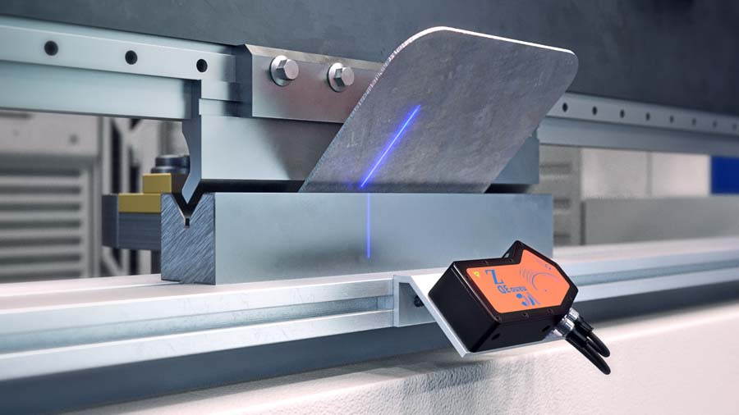
Caption: The laser profiler for real-time angle measurement in sheet metal bending press brakes can be directly connected to the machine's PLC

Notably, Vision Components' 3D laser triangulation systems operate autonomously, without an external computer. This provides customers with an extremely robust, low-maintenance, and cost-effective solution. Featuring a compact IP67 housing and a large field of view, VCnano3D-Z sensors are easy to integrate and can be used with different dies without any conversion or adjustment. The blue high-performance laser and Vision Components' proprietary ambient light suppression technology ensure reliable detection on shiny and reflective surfaces, for example when bending stainless steel, copper, brass, and foiled materials. The embedded vision system's 3D analysis is also designed to correctly detect perforated metal, checkered plate metal, and brushed aluminum. Few profile points are sufficient for precise angle measurement even with short sheet metal pieces. The embedded vision pioneer Vision Components, which celebrates its 25th anniversary in 2021, ensures the long-term availability of its products and supports machine builders and manufacturers of inspection systems in their application integration.
More: https://www.vision-components.com/en/products/oem/3d-systems/laser-profiler/pressbrake/

Image/s: | vcnano3d-z_press_brake | Characters: | 1651
File name: | 202106005_pm_angle_measure_press_brake_en | Date: | 06-09-2021
About Vision Components
Vision Components is a leading international manufacturer of embedded vision systems. The freely programmable cameras with powerful onboard CPUs perform image processing tasks on their own without the need for an additional computer. Vision Components offers OEMs versatile Linux-based embedded systems for 2D and 3D image processing, supplied as board cameras or in protective casings. These are complemented by a growing range of ultracompact MIPI camera boards, which connect to a variety of different CPU boards. In addition, Vision Components offers software libraries and develops customized solutions on request. The team of experts can draw on extensive knowledge and over 20 years of experience with imaging applications. The company based in Ettlingen in southwestern Germany was founded in 1996 by Michael Engel, the inventor of the first industrial-grade intelligent camera. More world premieres followed, including the world's first intelligent vision sensors and the first-ever embedded 3D laser profiler. Today, Vision Components has sales offices in the United States and Japan and works with local partners in over 25 countries to provide consistent customer focus and readily available expertise throughout the world.

Contact:  Vision Components GmbH  Jan-Erik Schmitt  Ottostr. 2  76275 Ettlingen  Germany  Phone: +49 . 7243 . 21670  Email: schmitt@vision-components.com  Internet: www.vision-components.com | gii die Presse-Agentur GmbH  Immanuelkirchstr. 12  10405 Berlin  Germany  Phone: +49 . 30 . 538 9650  Email: info@gii.de  Internet: www.gii.de

