Press Release

New diagnostics testers for fast DC charging stations

The demand for DC fast charging stations will continue to increase as the transition towards electromobility progresses. Since DC charging stations installed in public or commercially accessible areas are designated for the use by the general public, they must be tested for substantiation of electrical safety in accordance with DIN EN 61851-1 (VDE 0122-1), charging mode 4. Gossen Metrawatt has expanded its portfolio for mandatory functional testing, adding two new diagnostics testers (PROFITEST H+E XTRA and H+E XTRA C), which cover the two common system standards CCS (Combo 2) and CHAdeMO. After the testers have been connected to a charging station and after registration and selection of the test sequences, they perform simulated charging processes from a DC source and load to determine the charging current, charging time and voltage. In addition to measurements for insulation fault detection, DC voltage and direct current, the devices check data communication conformity with ISO 15118-1 or DIN SPEC 70121 for CCS stations or the respective relevant CHAdeMO protocol.

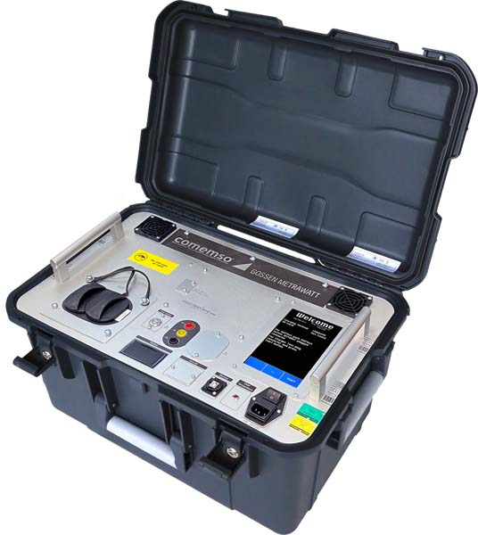
Caption: Gossen Metrawatt presents two new diagnostics testers for functional testing of fast DC charging stations under the CCS and CHAdeMO standards

A graphic color display with touch input ensures good readability and intuitive operation. In addition, the devices feature 4-mm safety sockets for DC+, DC- and PE for connecting a PROFITEST PRIME installation tester so all necessary measurements can be made under loading conditions to check the effectiveness of protective measures. Measuring tasks covered include checking the low-impedance continuity of the protective conductor; measuring the loop resistance between DC+ and DC-; insulation monitoring in the CCS system; measurements of insulation resistance, residual voltage and contact current; and function control of the residual current protective device.

Image/s: | profitest-he-xtra_persp1 | Characters: | 1748
File name: | 202204012_pm_e-charging_stations_en | Date: | 04-27-2022
About Gossen Metrawatt
Gossen Metrawatt, one of the world’s leading suppliers of measurement systems, develops and distributes a wide range of high-quality measuring and test devices for electrical trade, various industries and the public sector.
The Gossen Metrawatt brand has been synonymous with safety and quality “Made in Germany” for decades. Its product range includes measurement and test technology for the electrical safety of plants, devices and machines as well as for the e-mobility and medical technology industries. Additional key areas of interest are power quality, battery testing technology, multimeters, calibrators, power supply technology and energy management systems. For a truly comprehensive electrical safety portfolio, Gossen Metrawatt also offers a continuously growing range of digital services and cloud services and supports its customers with a versatile training program and a wide range of after-sales services.
Gossen Metrawatt is part of the GMC Instruments Group, which also includes other specialized manufacturers for measurement and testing technology – notably, Camille Bauer Metrawatt, Dranetz, Prosys, Seaward and Rigel and Kurth Electronic. The Camille Bauer and Rigel brands add to the portfolio various transducers, display instruments and detection systems for heavy-current engineering as well as special measuring, testing and functional testing devices for the medical sector. The GMC-I Group runs its own DAkkS-certified calibration center that performs DAkkS, ISO and factory calibrations for virtually all electrical measured quantities. The GMC-I Group has development and production sites in Germany, Switzerland, England and the USA and a worldwide sales network of its own companies as well as sales partners.
Contact:  Gossen Metrawatt GmbH  Christian Widder  Head of Marketing Communication  Suedwestpark 15  90449 Nuremberg  Germany  Phone: +49 . 911 . 8602-572  Email: christian.widder@gossenmetrawatt.com  Internet: www.gossenmetrawatt.com |  | gii die Presse-Agentur GmbH  Immanuelkirchstr. 12  10405 Berlin  Germany  Tel.: +49 . 30 . 538 9650  Email: info@gii.de  Internet: www.gii.de

