Press Release

Menzel goes digital and stays flexible

Menzel Elektromotoren has transferred to digital order management. As a result, the manufacturer of large industrial motors has shortened its response times and improved the quality of operational processes, whilst creating transparency through a unified data base, which is available to every employee in real time. From product inquiries to manufacturing processes and intralogistics, all data is now entered and transmitted electronically. Using the latest Human Interface (HID) tablet computers, staff can instantly document production progress, order material via an ERP interface, and access a comprehensive archive of technical drawings, checklists, guidelines, and manuals. By scanning the QR code on a drive system, employees and customers can easily access associated documentation at any time. Technical documentation for the customer can be automatically generated in up to seven languages in no time at all, thanks to a translation program especially implemented for Menzel. Time-consuming data synchronization and media disruption have been effectively eliminated.

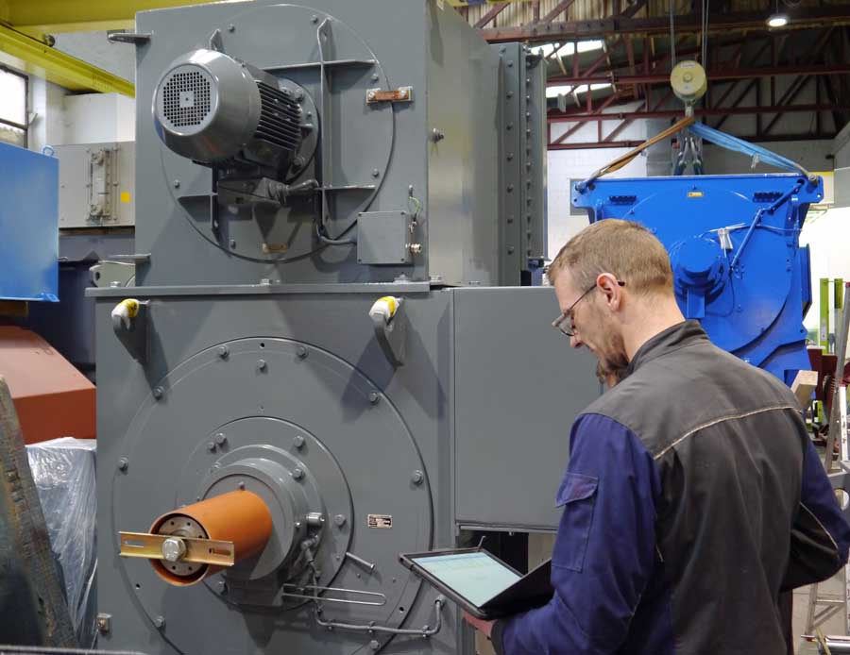
Illustration: Menzel Elektromotoren has converted to paperless order management, streamlining processes and fulfilling customer requirements even faster and more flexibly

Paperless data transfer and direct, automatic plausibility checks of inputs have improved data quality, whilst significantly reducing errors. Each production step is tracked and monitored, which increases inhouse transparency and process integrity. This allows for even better customer service. Menzel embraces the opportunities offered by the latest digital technologies, continuing to differentiate itself from the market to ensure fast and flexible fulfillment of customer requirements. Standardized, user-friendly processes as well as efficient information flows lay the basis for this. Further exciting digitization projects are already at advanced planning stages, all aiming to continuously improve manufacturing processes and provision of customer-focused, state-of-the-art three-phase asynchronous motors and DC motors for any application.
Direct request for industrial motors available worldwide: https://www.menzel-motors.com/enquiry/

Illustrations: | menzel_digital_order_mgmt | Char.s: | 1926
File name: | 201906019_pm_digitization_en | Date: | 06-19-2019
About Menzel Elektromotoren
Based in Berlin, Menzel Elektromotoren GmbH has been manufacturing and distributing electric motors for more than 90 years. The medium-sized company specializes in the delivery of large electric motors, including special models, within the shortest possible time. The product range comprises high and low voltage motors, DC motors, transformers, and frequency inverters. Services include motor production and short-term adaptation of stocked motors to application-specific requirements. In order to ensure fast deliveries to the customer at all times, the company maintains a very extensive inventory including more than 20,000 motors with a maximum performance of up to 15,000 kW. Qualified engineering, experienced staff, and state-of-the-art production and testing facilities help Menzel provide excellent reliability. Menzel operates subsidiaries in the UK, France, Italy, Spain, and Sweden, and cooperates with numerous partners worldwide.

Contact:  Menzel Elektromotoren GmbH  Mathis Menzel  Neues Ufer 19-25  10553 Berlin  Germany  Phone: +49 . 30 . 349 922 - 0  Fax: +49 . 30 . 349 922 - 999  Email: info@menzel-motors.com  Internet: www.menzel-motors.com | gii die Presse-Agentur GmbH  Immanuelkirchstr. 12  10405 Berlin  Germany  Phone: +49 . 30 . 538 965 - 0  Fax: +49 . 30 . 538 965 - 29  Email: info@gii.de  Internet: www.gii.de

