Press Release

embedded world:
Ultracompact stereo camera and new MIPI modules

Vision Components will present new MIPI modules and OEM components for time-saving embedded vision developments at the 2022 embedded world exhibition in Nuremberg. The German manufacturer will launch the VC Stereo Cam for 3D and two-camera applications. This stereo camera is based on the new FPGA hardware accelerator VC Power SoM, which can process large data volumes in real time. It captures images via two MIPI camera modules and executes sophisticated image pre-processing routines including, for example, 3D point cloud generation. The system's functions and hardware can be flexibly adapted for OEM applications. As with all its products, Vision Components ensures industrial suitability and long-term availability.

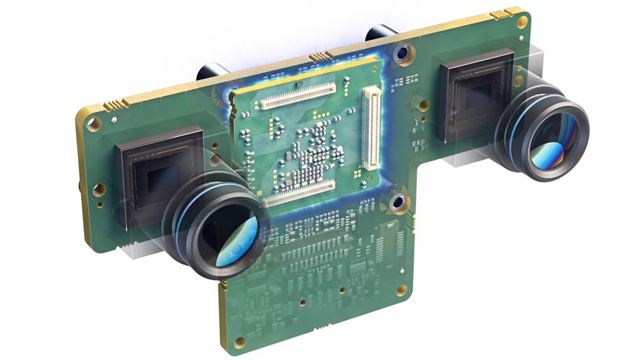
Caption: The new VC Stereo Cam with real-time image pre-processing saves vision OEMs a lot of development effort

New MIPI camera modules will also premiere at the trade fair, integrating various global shutter sensors from the Sony Pregius S series with minimal noise and high light sensitivity: IMX565, IMX566, IMX567 and IMX568. The wide range of Vision Components MIPI modules allows OEM customers to meet all requirements whatever their particular vision project, with cost-effective and high-resolution sensors, different shutter variants as well as sensors for SWIR and 3D/ToF applications. The modules with a MIPI interface, trigger input and flash trigger output are designed for easy connection to common single-board computers. Also on show will be embedded vision systems that combine image acquisition and processing on a single board. The latest and smallest of these OEM camera systems, VC picoSmart, has a footprint of only 22 mm x 23.5 mm. For 3D profile sensors based on the VC picoSmart, Vision Components also provides a suitable triangulation module. The team is looking forward to inquiries about the product range and possible applications.
Vision Components at embedded world
Nuremberg, Germany, 21 – 23 June 2022
Hall 2, Stand 450

Image/s: | vc_stereo_cam_board_camera | Characters: | 1772
File name: | 202205019_pm_embedded_world_en | Date: | 05-10-2022
About Vision Components
Vision Components is a leading international manufacturer of embedded vision systems. The freely programmable cameras with powerful onboard CPUs perform image processing tasks on their own without the need for an additional computer. Vision Components offers OEMs versatile Linux-based embedded systems for 2D and 3D image processing, supplied as board cameras or in protective casings. These are complemented by a growing range of ultracompact MIPI camera boards, which connect to a variety of different CPU boards. In addition, Vision Components offers software libraries and develops customized solutions on request. The team of experts can draw on extensive knowledge and over 20 years of experience with imaging applications. The company based in Ettlingen in southwestern Germany was founded in 1996 by Michael Engel, the inventor of the first industrial-grade intelligent camera. More world premieres followed, including the world's first intelligent vision sensors and the first-ever embedded 3D laser profiler. Today, Vision Components has sales offices in the United States and Japan and works with local partners in over 25 countries to provide consistent customer focus and readily available expertise throughout the world.
Contact:  Vision Components GmbH  Jan-Erik Schmitt  Ottostr. 2  76275 Ettlingen  Germany  Phone: +49 . 7243 . 21670  Email: schmitt@vision-components.com  Internet: www.vision-components.com |  | gii die Presse-Agentur GmbH  Immanuelkirchstr. 12  10405 Berlin  Germany  Phone: +49 . 30 . 538 9650  Email: info@gii.de  Internet: www.gii.de

