Press Release

automatica trade fair:
Acoustic imager for fixed and agile robotic inspection

Fluke Process Instruments will be a co-exhibitor at Holland Robotics’ automatica booth (#B4.119) in Munich, Germany, showcasing its new SV600 Fixed Acoustic Imager, which enables users to detect, locate and track air or gas leaks before they incur high maintenance and repair costs. The focus will be on agile robotic applications for the acoustic camera: the SV600 has been integrated in Boston Dynamics’ robot dog Spot, which enables monitoring in difficult-to-access or potentially unsafe environments. There will be live demonstrations of the technology at the automatica booth every two hours. Using an array of sophisticated sound sensors, a camera and Fluke’s powerful SoundMap technology, the SV600 visualizes sounds for asset monitoring, troubleshooting and quality inspection. It easily integrates with factory systems and, as a mounted device, enables 24/7 monitoring of compressors, pumps, pipes and other equipment with user-defined alarms. Remote evaluation options help minimize operator intervention, thus improving factory safety.
More information: https://www.flukeprocessinstruments.com/en-us/products/sv600-fixed-acoustic-imager

Fluke Process Instruments at automatica
Munich, Germany, 21 – 24 June 2022
Hall B4, Stand 119 (with Holland Robotics)

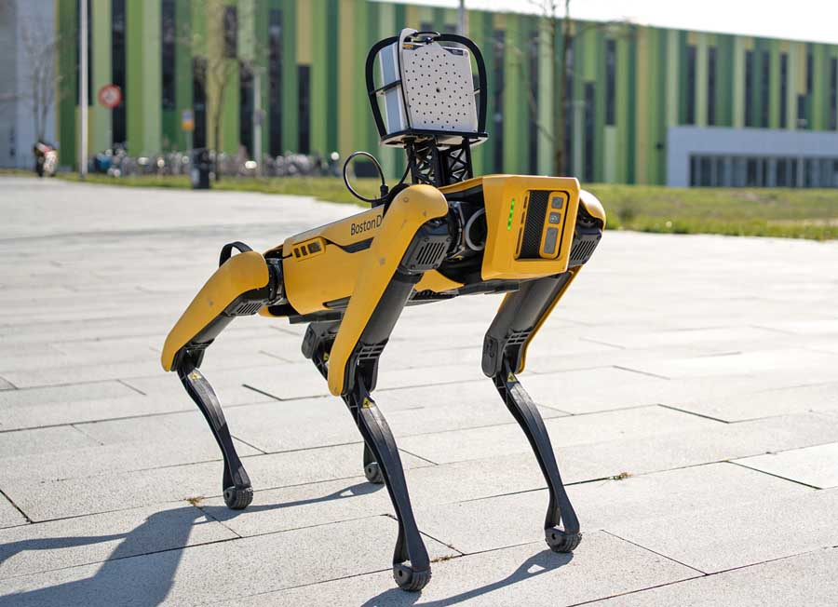
Caption: The SV600 Fixed Acoustic Imager for gas leak detection is also available as a payload for the agile robot Spot

Image/s: | sv600_mounted_on_spot | Characters: | 1047
File name: | 202206025_pm_sv600_automatica_en | Date: | 06-14-2022
About Fluke Process Instruments
Fluke Process Instruments designs, manufactures, and markets a complete line of infrared temperature measurement and profiling solutions for industrial, maintenance, and quality control applications. Distributed worldwide under the Raytek, Ircon, and Datapaq brands, the products reflect the combined experience of over 150 years in manufacturing the world’s finest temperature measurement tools and devices.
About Fluke
Founded in 1948, Fluke Corporation is the world leader in compact, professional electronic test tools. Fluke customers are technicians, engineers, electricians, and metrologists who install, troubleshoot, and manage industrial, electrical, and electronic equipment and calibration processes.
Contact:  Fluke Process Instruments GmbH  Blankenburger Str. 135  13127 Berlin  Germany  Phone: +49 . 30 . 478 008-0  Email: marketing@flukeprocessinstruments.de  Internet: www.flukeprocessinstruments.com |  | gii die Presse-Agentur GmbH  Immanuelkirchstr. 12  10405 Berlin  Germany  Phone: +49 . 30 . 538 9650  Email: info@gii.de  Internet: www.gii.de

