Press Release

productronica: Temperature profilers for reflow processes

At the productronica trade fair in Munich, Germany, Fluke Process Instruments (booth #A1-325) will present tested and proven temperature profiling systems for quality assurance in electronics manufacturing. The extensive portfolio includes comprehensive hardware and software solutions for both fully automated production lines and for rework and manual inspection. These systems travel along with the PCBs through every stage of the process including the preheating phase, capturing detailed temperature profiles along the way based on data gathered by up to 12 sensors. The Datapaq Reflow Tracker line comprises industry-specific data loggers, thermal barriers, a wide selection of thermocouples and the Datapaq Insight software, which quickly transforms raw data into actionable information and features functions for easy oven setup. The new Datapaq Insight for Mobile app allows users to quickly check thermocouple operation and analyze data on the factory floor, without the need for a PC. The latest generation of data loggers, the Datapaq DP5 series, provides a ±0.5 °C accuracy and a ±0.1 °C resolution. One logger can survey up to 10 ovens in succession, storing individual profiles with up to 600k data points in total. Fluke Process Instruments is continuously adding new Datapaq temperature profiling solutions to its portfolio. Standard and customized products are developed in close exchange with customers to optimally suit practical requirements.

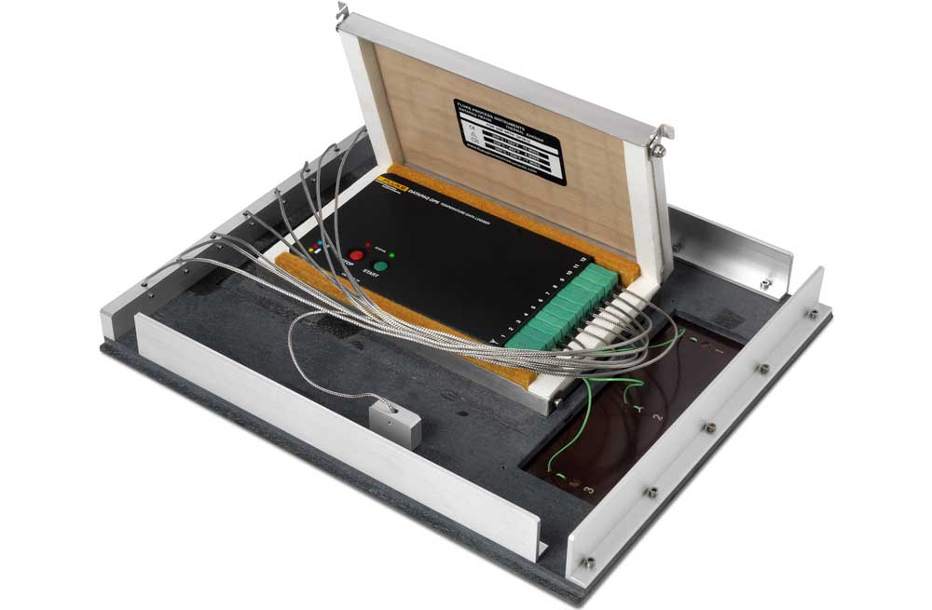
Caption: Datapaq Reflow Tracker temperature profiling systems are available with a wide range of data loggers and accessories such as the wave solder pallet here pictured

In addition, Fluke Process Instruments will also showcase infrared technology for noncontact temperature measurement. Applications for the ThermoView TV40 thermal imager include, amongst others, the quick detection of faulty solder joints. Another highlighted product line, the versatile Raytek Compact MI3 pyrometer series, is designed especially for easy integration in plants and machines and minimal costs per measurement point. The team will be happy to advise productronica visitors on the best way to tackle their specific measurement and monitoring tasks.
Fluke Process Instruments at the productronica trade fair
Munich, Germany, 16 – 19 November 2021
Hall A1, Stand 325

Image/s: | dp5_wave_solder_pallet | Characters: | 2026
File name: | 202110020_pm_productronica_preview_en | Date: | 11-10-2021
About Fluke Process Instruments
Fluke Process Instruments designs, manufactures, and markets a complete line of infrared temperature measurement and profiling solutions for industrial, maintenance, and quality control applications. Distributed worldwide under the Raytek, Ircon, and Datapaq brands, the products reflect the combined experience of over 150 years in manufacturing the world’s finest temperature measurement tools and devices.
About Fluke
Founded in 1948, Fluke Corporation is the world leader in compact, professional electronic test tools. Fluke customers are technicians, engineers, electricians, and metrologists who install, troubleshoot, and manage industrial, electrical, and electronic equipment and calibration processes.
Contact:  Fluke Process Instruments GmbH  Blankenburger Str. 135  13127 Berlin  Germany  Phone: +49 . 30 . 478 008-0  Email: marketing@flukeprocessinstruments.de  Internet: www.flukeprocessinstruments.com |  | gii die Presse-Agentur GmbH  Immanuelkirchstr. 12  10405 Berlin  Germany  Phone: +49 . 30 . 538 965-0  Email: info@gii.de  Internet: www.gii.de

