Press Release

CONTA-SUPERVISION IoT portal for remote monitoring and control via web and app

Conta-Clip has introduced the new IoT portal CONTA-SUPERVISION to complement its solutions for remote monitoring and control of processes and plants. Users can now access process data in real time and control GSM-PRO2 4G communication modules via a web browser or app. The solution works independently of existing IT infrastructures and also in remote places. Data from sensors is continuously updated and critical states are reported with push messages. The execution of control commands is confirmed separately. Users gain direct, clear insight into critical processes and can minimize downtime. The system can be modularly expanded and also displays data from interface extensions to the communication modules. The GSM-PRO2 modules are used in various applications from complex factory automation systems to remote facilities without network connection. They use 4G, 3G and 2G frequency bands from any provider with a contract or prepaid SIM card and, in addition to monitoring via the CONTA-SUPERVISION portal, can also send information and alarms via text message. Conta-Clip offers free-of-charge operation of up to two GSM-PRO2 modules via the IoT portal.
More information: https://conta-clip.com/en/conta-supervision/

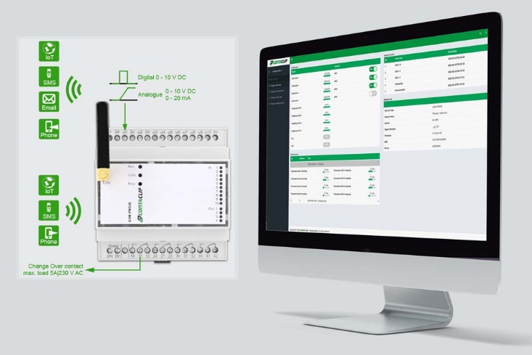
Caption: The CONTA-SUPERVISION IoT portal offers real-time access to process data from 4G modules independently of existing IT networks and allows their remote control

Image/s: | conta-supervision_gsm_pro | Characters: | 1162
File name: | 202304016_pm_gsm-pro2_conta-supervision_en | Date: | 04-25-2023
About CONTA-CLIP
CONTA-CLIP is one of Europe’s leading manufacturers of electrical and electronic connection elements and cable management solutions. Based in Hövelhof, Germany, the medium-sized, family-run company has been producing electric and electronic connection systems for the process and automation industries since 1978. CONTA-CLIP supplies all industry sectors, focusing on railroad industries, shipbuilding, building automation, conveyor technology, machine and plant engineering and construction, instrumentation and control technology, control panel manufacturing, transformer manufacturing, and environmental technology. The company consists of many specialized branches: CONTA-CONNECT for electric connection technology, CONTA-CABLE for cable management systems, CONTA-ELECTRONICS for electronics and CONTA-CON for PCB edge connectors. Additionally, CONTA-CLIP provides services such as customizing housings and mounting rails, labeling and supplying user-specific electronic components.
Contact:  CONTA-CLIP  Verbindungstechnik GmbH  Franziska Klein  Otto-Hahn-Str. 7  33161 Hövelhof  Germany  Phone: +49 . 5257 . 9833 - 173  Email: franziska.klein@conta-clip.de  Internet: www.conta-clip.com |  | gii die Presse-Agentur GmbH  Immanuelkirchstr. 12  10405 Berlin  Germany  Phone: +49 . 30 . 538 965 - 0  Email: info@gii.de  Internet: www.gii.de

