Press Release

Low-temperature proximity switches for easy direct connection in Ex zones 0/20

EGE provides IGEX20Pa-type proximity switches that withstand low temperatures down to -60 °C. ATEX- and IECEx-certified for use in Ex zones 0 and 20, these sensors can be used in hazardous areas with gas or dust atmospheres, for example in filling stations and facilities with gas pipelines etc. EGE now also offers easy-installation variants of these Polar-series proximity switches. Featuring the ignition protection type Ex m (encapsulation), these IGEX20Pa models can be employed in Ex zones 0 and 20 by themselves, without the need for additional switching amplifiers. EGE supplies the sensors with IP67 and IP68 ingress protection and in M12, M18, and M30 designs. Given a flush installation, the nominal switching distances are 2 mm, 5 mm, and 10 mm, depending on the design. The proximity switches are connected via a 2-m FEP cable. EGE supplies them with different cable lengths on request.

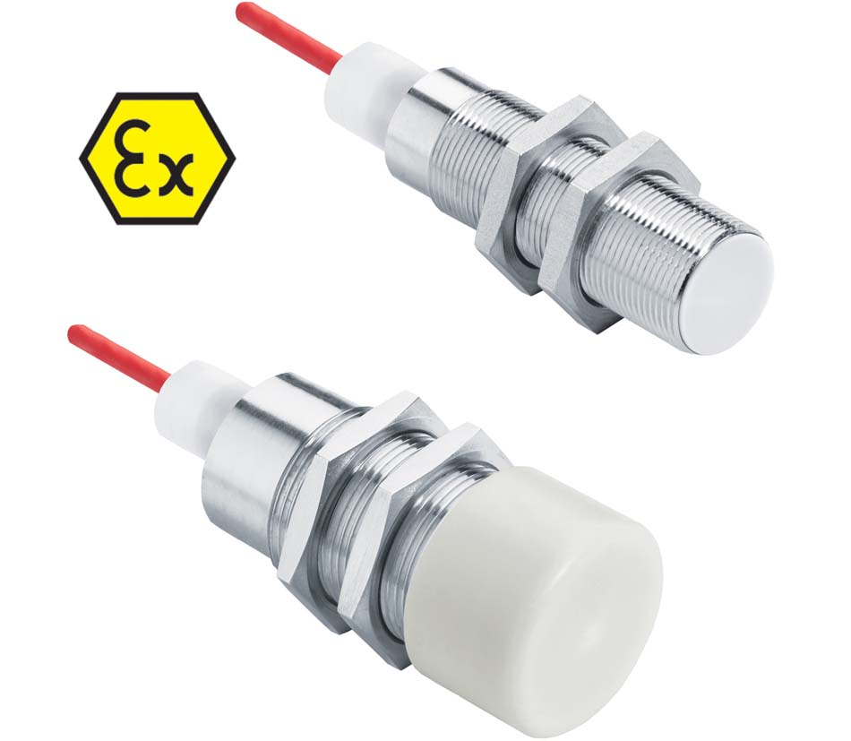
Caption: IGEX20Pa ATEX- and IECEx-certified proximity switches withstand freezing temperatures down to -60 °C

Image/s: | IGEX20PA | Characters: | 899
File name: | 201911033_pm_igexpa_proximity_switches_en | Date: | 03-18-2020
About EGE
EGE-Elektronik Spezial-Sensoren GmbH has been developing and manufacturing special purpose sensors for automation applications since 1976. The company serves leading international producers from a wide range of industries. Its product portfolio includes flow controllers, infrared, opto and ultrasonic sensors, capacitive proximity switches, light barriers and inductive proximity switches. EGE also provides sensors for highly sensitive applications, e.g. hazardous areas. The development department's highly qualified staff cooperates closely with all customers, ensuring continuous product updates and enhancement. A total of 89 employees, including 20 engineers and technicians, generate gross sales of approx. 19.5 million Euros worldwide.

Contact:  EGE-Elektronik Spezial-Sensoren GmbH  Sven-Eric Hiss  Ravensberg 34  24214 Gettorf  Germany  Phone: +49 . 4346 . 4158-0  Fax: +49 . 4346 . 5658  Email: info@ege-elektronik.com  Internet: www.ege-elektronik.com | gii die Presse-Agentur GmbH  Immanuelkirchstr. 12  10405 Berlin  Germany  Phone: +49 . 30 . 538 965-0  Fax: +49 . 30 . 538 965-29  Email: info@gii.de  Internet: www.gii.de

