Press Release

Heavy-duty trolley with freely adjustable turntable

The intra-logistics specialist LOSYCO has expanded its LOXrail system, adding a new automatic trolley with a rotating loading platform for flexible orientation of heavy workpieces directly on rails. This solution, which has already been successfully implemented in a machine factory, increases flexibility in assembly line layouts and simplifies the adaptation of the rail transport system to existing production lines and floor plans. The new trolley can be realized in different dimensions according to customer requirements. It enables manual or motor-driven rotation and orientation of payloads up to 10 tons. Application areas include laser and robot welding cells, measuring machines, feeding systems and other production systems requiring highly precise positioning and easy access to workpieces. The turntables can be powered via drives installed at the respective work stations or onboard drives fed via cable, energy guiding chain, battery or induction. LOSYCO is thus expanding its adaptable range of LOXrail-based transport systems for production logistics, material flow and machine loading and unloading, which ranges from manually moved trolleys to shuttles and transport platforms with sensor-controlled automatic braking to versions with mechanical or semi-automatic steering.

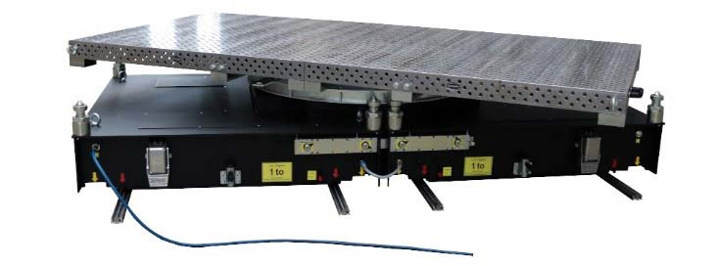
Caption 1: Trolley with manual rotating platform for high-precision feeding of a laser welding cell

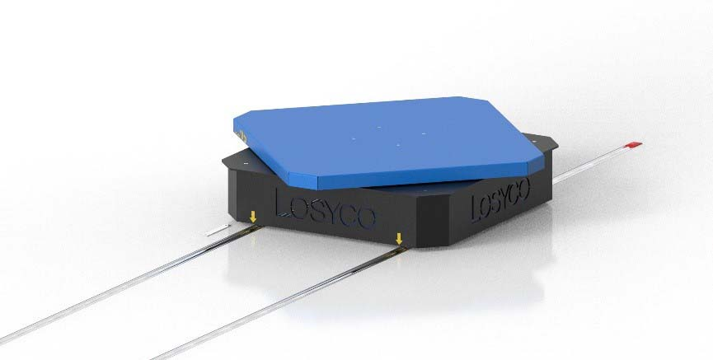
Caption 2: Functional model of the new LOXrail transport trolley with manually adjustable turntable for flexible orientation of loads directly on the intra-logistics rails

Image/s: | drehtellerplattform_frei_2000px.jpg  wagen-drehladeflaeche_2000.jpg | Characters: | 1293
File name: | 202305019_pm_turntable_en | Date: | 05-31-2023
About Losyco
LOSYCO designs, builds, and installs intra-logistics systems for the manufacturing industry. The company based in Bielefeld, Germany, was founded by experienced engineers in 2016. LOSYCO’s core product is the LOXrail® floor rail system for easy transport and precise positioning of loads weighing several tons. LOXrail transport platforms can be operated manually or with auxiliary drives. LOSYCO also supplies handling equipment such as chain and roller conveyors, material management and storage systems, as well as sound-proof cabins and machine covers. LOSYCO supports customers wishing to transform their production processes to lean manufacturing and continuous flow production. LOSYCO is a member of the DRECKSHAGE Family.
Contact:  LOSYCO GmbH  Member of the DRECKSHAGE Family  Manuel Granz  Walter-Werning-Str. 7  33699 Bielefeld  Germany  Tel.: +49 . 521 . 945 643-0  Email: info@losyco.com  Internet: www.losyco.com |  | gii die Presse-Agentur GmbH  Immanuelkirchstr. 12  10405 Berlin  Germany  Tel.: +49 . 30 . 538 965-0  Email: info@gii.de  Internet: www.gii.de

