Press Release

New SWIR lenses for micro-inspection

Qioptiq, an Excelitas Technologies company, introduces newly expanded capabilities of its Optem FUSION micro-inspection lens system, redesigned to meet the growing need for shortwave infrared (SWIR) sensors that enable the machine vision requirements essential to Industry 4.0 manufacturing. The lens system now provides true polychromatic imaging performance across the key Visible (400 nm – 700 nm), NIR (700 nm – 1100 nm) and SWIR (900 nm – 1700 nm) wavebands. The Optem FUSION micro-inspection system leverages field-proven mechanics, flexible optics and modular interchangeability, eliminating the complexities, long development cycles and high costs that can be associated with custom imaging solutions.

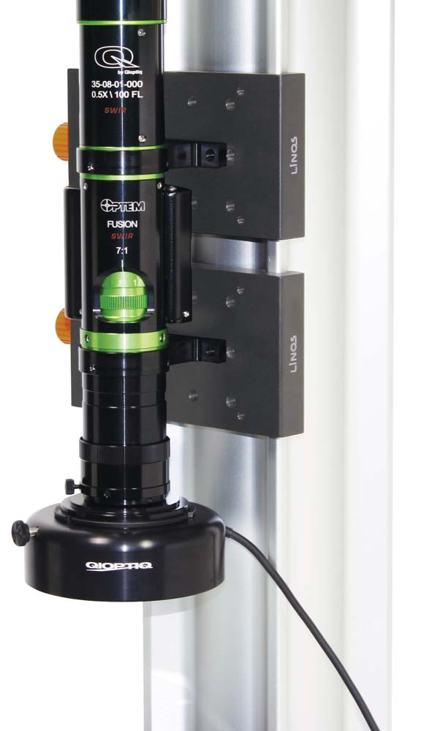
Illustration: The modular Optem FUSION micro-inspection system enables high-res imaging in the VIS to SWIR spectrum

To provide high performance and versatile SWIR imaging across a large variety of magnifications and working distances, Qioptiq adapted and carefully optimized SWIR-compatible components across a select range of its Optem FUSION lens system including:
- Lower objective lenses, with numerous magnifications and working distances
- 7:1 zoom module
- Fixed-magnification system
- Camera tube lenses with a range of magnifications for various sensor sizes and mount types
- Beam splitter for critical coaxial illumination support
The new SWIR lenses support all SWIR cameras currently available on the market. They can also be adapted to exotic cameras. Zoom and focus operations can be motorized to enable fully automated inspection solutions. By combining the field-proven visible range performance of Optem FUSION with new capabilities for reaching additional wavebands, the new SWIR lens system enables hyperspectral and multispectral imaging. Due to the universal concept of the Optem FUSION micro-imaging lens system, optical solutions spanning 400 nm to 1700 nm with optimized image sensors are now possible for the first time under a single platform, opening entirely new approaches to machine vision demanded by Industry 4.0. “Machine vision plays a fundamental role in automation systems for Industry 4.0, which will increasingly rely on information from sensors and visual systems to identify product defects, understand the root of their deficiencies and enable real-time effective intervention and correction,” said Michael Bulk, application engineer at Excelitas. “Pushing the classic inspection window beyond the visible wavelength range enables the development of exciting new techniques and applications including new alignment techniques and material identification.”

Illustrations: | optem_fusion_swir_7in_assembly | Char.s: | 2484
File name: | ENpm_2019_06-20_QIO_optem-fusion-swir | Date: | 06-20-2019
Tags: | 3 - OL - Optical Inspect | GPI: | 201906011

About Excelitas Technologies

Excelitas Technologies® Corp. is a global technology leader focused on delivering innovative, high-performance, market-driven photonic solutions to meet the lighting, optronics, detection and optical technology needs of global customers. Serving a vast array of applications across biomedical, scientific, safety, security, consumer products, semiconductor, industrial manufacturing, defense and aerospace sectors, Excelitas Technologies stands committed to enabling our customers' success in their end-markets. Excelitas Technologies has approximately 6,700 employees in North America, Europe and Asia, serving customers across the world. Connect with Excelitas on Facebook, LinkedIn and Twitter.

About Qioptiq

Qioptiq designs and manufactures photonic products and solutions that serve a wide range of markets and applications in the areas of medical and life sciences, industrial manufacturing, defense and aerospace, and research and development. Qioptiq benefits from having integrated the knowledge and experience of Avimo, Gsänger, LINOS, Optem, Pilkington, Point Source, Rodenstock, Spindler & Hoyer and others.

Contact:  Excelitas Technologies Corp.  Oliver Neutert  Regional Marketing Manager EMEA  Feldkirchen (near Munich)  Germany  Phone: +49 89-255458-965  Email: oliver.neutert@excelitas.com  Internet: www.excelitas.com | gii die Presse-Agentur GmbH  Immanuelkirchstr. 12  10405 Berlin  Germany  Phone: +49 30-538965-0  Email: info@gii.de  Internet: www.gii.de

