Press Release

New management generation at LOSYCO

German intra-logistics specialist LOSYCO announces a generational change on the executive level. As of the beginning of 2020, Manuel Granz and Christoph W. Münter manage the operational business of the internationally successful provider of LOXrail handling solutions. The two new managing directors used to be in charge of sales and technology in a managerial capacity. LOSYCO was founded as a startup in 2016 by experienced intra-logistics expert Derek P. Clark who remains a shareholder of the company and will continue to support its sales activities. LOSYCO's core business is planning, development, construction, and commissioning of rail-based conveyor systems for heavy-duty intra-logistics transport, for instance in machine and plant engineering. The portfolio includes tailor-made LOXrail solutions, various drive technologies, and the integration of material and media provision. In addition, LOSYCO supports manufacturers wishing to streamline their production logistics through conversion to one-piece flow. Smaller businesses can get a free check-up of their production facilities' potential for efficiency optimization. For input on the latest advances in scientific research, the company cooperates with research facilities such as the IWT institute for economic and technological management at the TH OWL university of applied sciences and arts in Detmold, Germany.

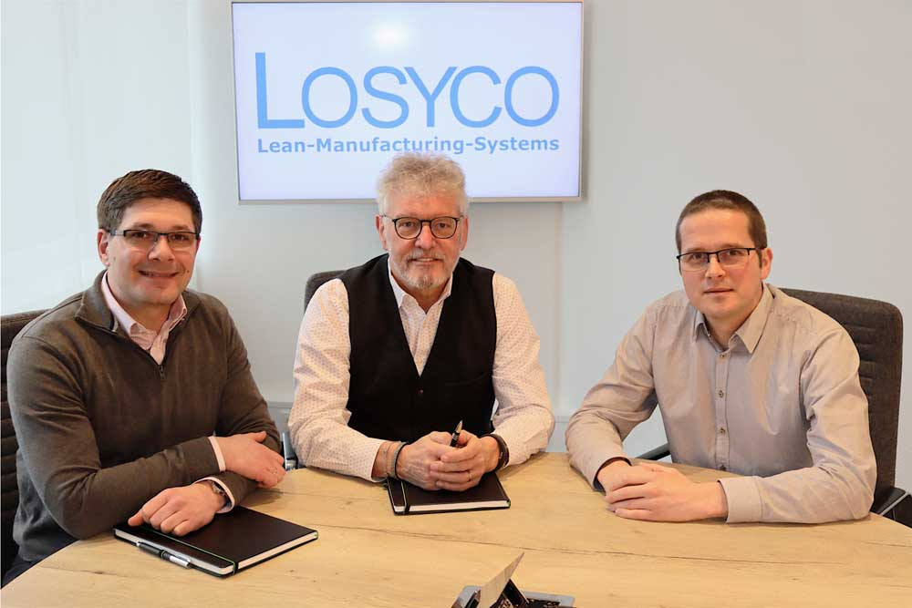
Caption: New management generation at LOSYCO: Manuel Granz (left) and Christoph W. Münter (right) take over from company founder Derek P. Clark (middle)

Image/s: | gf_granz_muenter_2000 | Characters: | 1383
File name: | 202002013_pm_new_management_en | Date: | 02-05-2020
About Losyco
Based in Bielefeld, Germany, Losyco designs, manufactures, and deploys intra-logistics systems for industrial customers. Founded by experienced engineers in 2016, the company's first core product is LOXrail®: with this novel round bar rail system, loads weighing several tons can be easily moved around, precisely to the desired spot. It can be operated manually or with auxiliary drives. Losyco also supplies conveying and handling equipment such as chain and roller conveyors, material management and storage systems, sound-proof cabins, and machine covers. In addition, Losyco offers support and guidance for customers wishing to transform their production processes to implement lean manufacturing and continuous flow production. Losyco is a member of the DRECKSHAGE Family.

Contact:  LOSYCO GmbH  Member of the DRECKSHAGE Family  Manuel Granz  Walter-Werning-Str. 7  33699 Bielefeld  Germany  Tel.: +49 . 521 . 945 643-0  Fax: +49 . 521 . 945 643-399  Email: info@losyco.com  Internet: www.losyco.com | gii die Presse-Agentur GmbH  Immanuelkirchstr. 12  10405 Berlin  Germany  Tel.: +49 . 30 . 538 965-0  Fax: +49 . 30 . 538 965-29  Email: info@gii.de  Internet: www.gii.de

