Press Release

Crane motors with exactly replicated interfaces

Menzel Elektromotoren has manufactured four crane motors with the exact electrical and mechanical interfacing positions of a make that is no longer available today. The new slip ring motors based on a cost-efficient motor series will drive hoists on overhead cranes in a Chilean cement plant. Since standard motors do not fit the existing positions and dimensions for feet, shafts and shaft height, and since constructive changes on the cranes are impossible or not desirable due to technical and safety approvals, Menzel tailored foot adapter rails. The motors have two shaft ends, with the drive end coupled to the gearbox, which connects to the rope drum, and a brake installed on the non-drive end. At the customer’s request, the stator and rotor connections are implemented in a common terminal box, which is symmetrically positioned and can be simply rotated in the direction of the connection cables. This allows the customer to deploy the motors in different locations with limited space. The slip ring motors from the energy-efficient, low-noise MEBSGR series provide high starting torques at low starting currents and have a high overload capacity. They have a rated power of 63 kW, a rated voltage of 550 V and a rated torque of 617 Nm. The motors are designed for periodic intermittent operation (S3 40%). As a family-run, medium-sized manufacturer, Menzel is very customer-oriented, responds flexibly to special requests and can therefore also serve those inquiries that many competitors routinely reject for requiring too much effort. The crane motors adapted for the cement manufacturer fit exactly in terms of electrical performance data and mounting dimensions and can be directly mounted on the cranes.
Motors for cranes and hoists: https://www.menzel-motors.com/crane-drive/

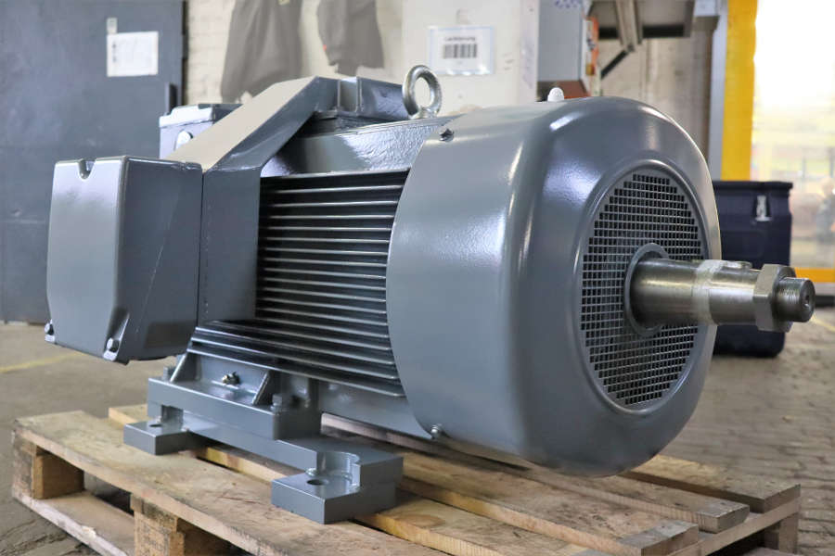
Caption: Menzel's tailored solution ensures full mechanical and electrical interchangeability

Image/s: | hoist_motor_cement_plant | Characters: | 1720
File name: | 202209005_pm_crane_motors_cement_en | Date: | 10-05-2022
About Menzel Elektromotoren
Based in Berlin, Menzel Elektromotoren GmbH has been manufacturing and distributing electric motors since 1927. The medium-sized company specializes in the delivery of large electric motors, including special models, within the shortest possible time. The product range comprises high and low voltage motors, DC motors, transformers, and frequency inverters. Services include motor production and short-term adaptation of stocked motors to application-specific requirements. In order to ensure fast deliveries to the customer at all times, the company maintains a very extensive inventory including more than 20,000 motors with a maximum performance of up to 15,000 kW. Qualified engineering, experienced staff, and state-of-the-art production and testing facilities help Menzel provide excellent reliability. Menzel operates subsidiaries in the UK, France, Italy, Spain, and Sweden, and cooperates with numerous partners worldwide.
Contact:  Menzel Elektromotoren GmbH  Mathis Menzel  Neues Ufer 19 – 25  10553 Berlin  Germany  Phone: +49 . 30 . 349 922-0  Email: info@menzel-motors.com  Internet: www.menzel-motors.com |  | gii die Presse-Agentur GmbH  Immanuelkirchstr. 12  10405 Berlin  Germany  Phone: +49 . 30 . 538 9650  Email: info@gii.de  Internet: www.gii.de

