Press Release

Seifert showcases thermal management solutions in Dubai and New Delhi

Seifert Systems presents a cross-section of its product range for professional air conditioning of industrial equipment and control cabinets at two major international trade fairs in the United Arab Emirates and India. On 6 to 8 March, the company is at the Middle East Electricity fair in Dubai, the region's leading exhibition for power generation, transmission, and distribution. At the ELECRAMA fair, one of India's largest trade fairs for the electricity industry, which takes place in New Delhi on 10 to 14 March, Seifert Systems will exhibit thermal management solutions. Product showcases at both trade fairs will include air conditioners, Peltier cooling systems for both indoor and outdoor use, heat exchangers, filter fans, cabinet accessories, and LED enclosure lighting. "As a globally operating company, an international outreach and visible presence in all major markets is important to us", says Michael Seifert, CEO of the Seifert Systems Group. "Every market has specific requirements and development trends. Through direct contact with our international customers we are familiar with all their particular expectations and develop products to meet their needs."

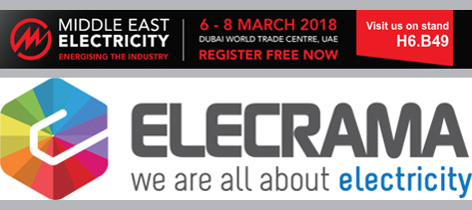
Illustration: Seifert Systems presents state-of-the-art thermal management technology at two international exhibitions in Dubai and New Delhi in March 2018

Illustrations: | messebanner_dubai-delhi | Char.s: | 1,180
File name: | 201803010_pm_dubai_delhi_en | Date: | 03-05-2018

Contact:  Seifert Systems Ltd.  Ingo Sausmekat  Head of Marketing  HF 09/10 Hal Far Industrial Estate  Birzebbuga  Malta  Phone: +356 2220 7264  Email: info@seifertsystems.com  Web: www.seifertsystems.com |  | gii die Presse-Agentur GmbH  Immanuelkirchstr. 12  10405 Berlin  Germany  Phone: +49 . 30 . 538 9650  Fax: +49 . 30 . 5389 6529  Email: info@gii.de  Web: www.gii.de

