Press Release

New MIPI camera modules with Sony Pregius S sensors

Vision Components has integrated four new Sony Pregius S sensors into MIPI camera modules for embedded vision. Featuring high image quality, light sensitivity and readout rates, the IMX565, IMX566, IMX567 and IMX568 global shutter sensors are perfect for high-speed applications such as industrial inspection. The VC carrier boards are designed for efficient repeatable industrial processing: robust, with excellent heat dissipation and prefabricated mounting holes and precision fittings. The MIPI-CSI-2 port allows for easy connection to all common processor platforms. Vision Components supplies high-performance cables and other accessories perfectly matched to the boards from a single source and provides customers with proven drivers free of charge. This enables vision OEMs to bring their projects to series maturity faster, with less effort and lower costs. Vision Components is continuously expanding its VC MIPI portfolio, adding more image sensors, accessories and developer kits. Specific sensors can be integrated on request. The new MIPI camera modules will premiere at the embedded world exhibition in Nuremberg, Germany. Series production of some models has already begun.
More information: www.mipi-modules.com

Vision Components at embedded world
Nuremberg, Germany, 21 – 23 June 2022
Hall 2, Stand 450

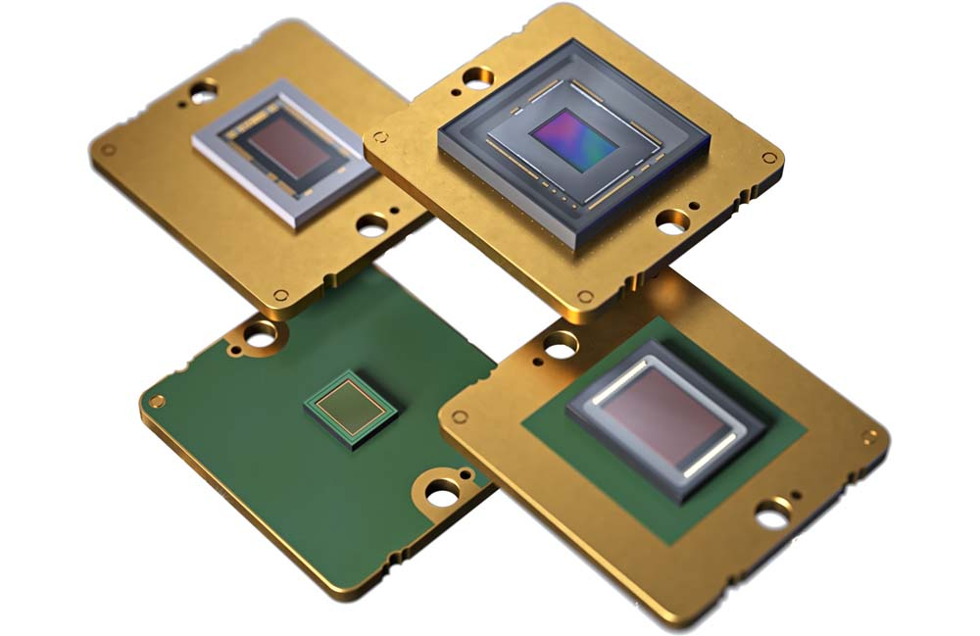
Caption: Vision Components offers one of the most comprehensive portfolios of MIPI camera modules and has now added four Sony Pregius S global shutter sensors

Image/s: | vc_mipi_camera_modules_lineup_4 | Characters: | 1189
File name: | 202206022_pm_new_mipi_camera_modules_en | Date: | 06-14-2022
About Vision Components
Vision Components is a leading international manufacturer of embedded vision systems. The freely programmable cameras with powerful onboard CPUs perform image processing tasks on their own without the need for an additional computer. Vision Components offers OEMs versatile Linux-based embedded systems for 2D and 3D image processing, supplied as board cameras or in protective casings. These are complemented by a growing range of ultracompact MIPI camera boards, which connect to a variety of different CPU boards. In addition, Vision Components offers software libraries and develops customized solutions on request. The team of experts can draw on extensive knowledge and over 20 years of experience with imaging applications. The company based in Ettlingen in southwestern Germany was founded in 1996 by Michael Engel, the inventor of the first industrial-grade intelligent camera. More world premieres followed, including the world's first intelligent vision sensors and the first-ever embedded 3D laser profiler. Today, Vision Components has sales offices in the United States and Japan and works with local partners in over 25 countries to provide consistent customer focus and readily available expertise throughout the world.
Contact:  Vision Components GmbH  Jan-Erik Schmitt  Ottostr. 2  76275 Ettlingen  Germany  Phone: +49 . 7243 . 21670  Email: schmitt@vision-components.com  Internet: www.vision-components.com |  | gii die Presse-Agentur GmbH  Immanuelkirchstr. 12  10405 Berlin  Germany  Phone: +49 . 30 . 538 9650  Email: info@gii.de  Internet: www.gii.de

